Pressure Gauge
# Source: AI Source: Provided by: [Data Path: Persons Table -> ID Column: 1, Name_En Column: Motasem Essam] -> From: [ChatGPT] on [7/17/2026]
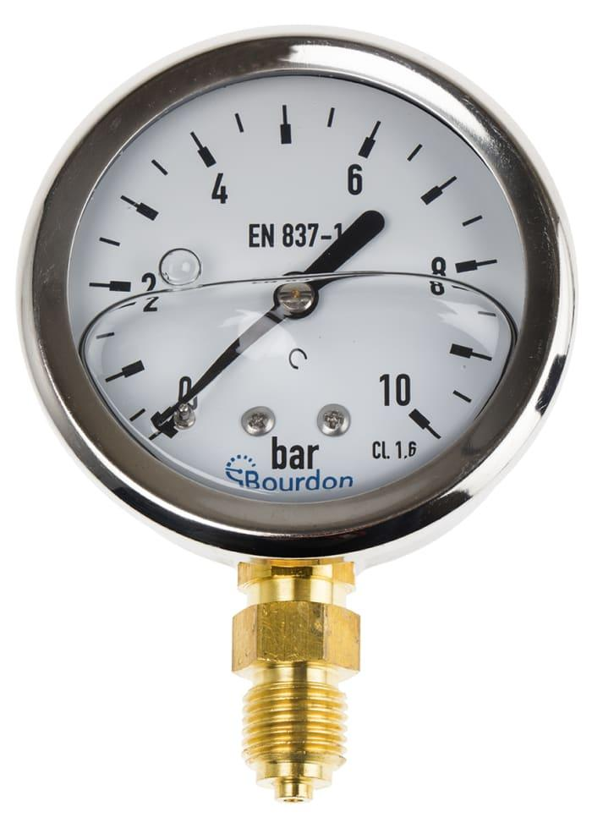
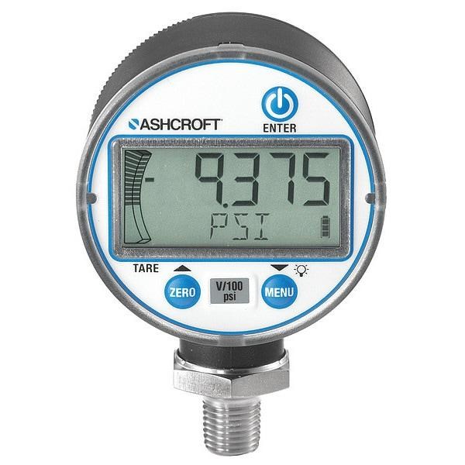
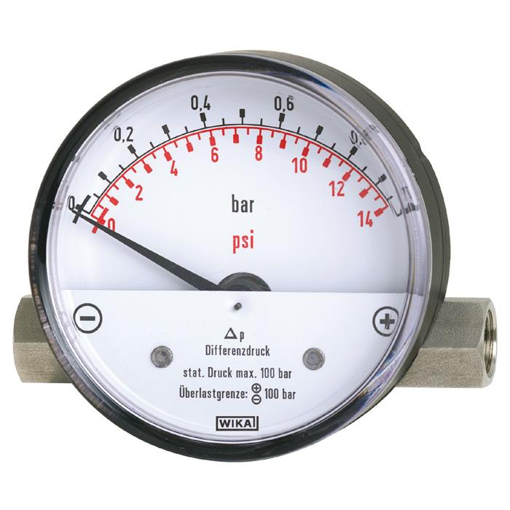
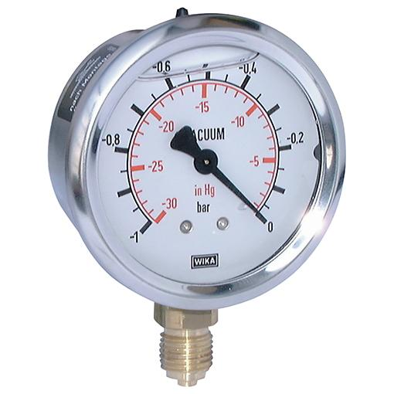
A Pressure Gauge is an instrument used to measure the pressure of gases or liquids inside a closed system. It is one of the most common measuring instruments used in industry, laboratories, hydraulic systems, pneumatic systems, HVAC, power plants, and process control.
Pressure gauges are available in mechanical and electronic (digital) designs and can measure positive pressure, vacuum, compound pressure, or differential pressure.

Definition
# Source: AI Source: Provided by: [Data Path: Persons Table -> ID Column: 1, Name_En Column: Motasem Essam] -> From: [ChatGPT] on [7/17/2026]
A Pressure Gauge is an instrument that measures the pressure exerted by a gas or liquid relative to a reference pressure.

Purpose
# Source: AI Source: Provided by: [Data Path: Persons Table -> ID Column: 1, Name_En Column: Motasem Essam] -> From: [ChatGPT] on [7/17/2026]
A pressure gauge is used to:
- Measure fluid pressure.
- Monitor hydraulic systems.
- Monitor pneumatic systems.
- Ensure equipment operates safely.
- Detect leaks or blockages.
- Control industrial processes.

Principle of Operation
# Source: AI Source: Provided by: [Data Path: Persons Table -> ID Column: 1, Name_En Column: Motasem Essam] -> From: [ChatGPT] on [7/17/2026]
The applied pressure acts on a sensing element.
- In mechanical gauges, pressure deforms a Bourdon tube, diaphragm, or capsule.
- In digital gauges, pressure acts on an electronic pressure sensor that converts pressure into an electrical signal.
The deformation or electrical signal is converted into a pressure reading.

Main Components
# Source: AI Source: Provided by: [Data Path: Persons Table -> ID Column: 1, Name_En Column: Motasem Essam] -> From: [ChatGPT] on [7/17/2026]
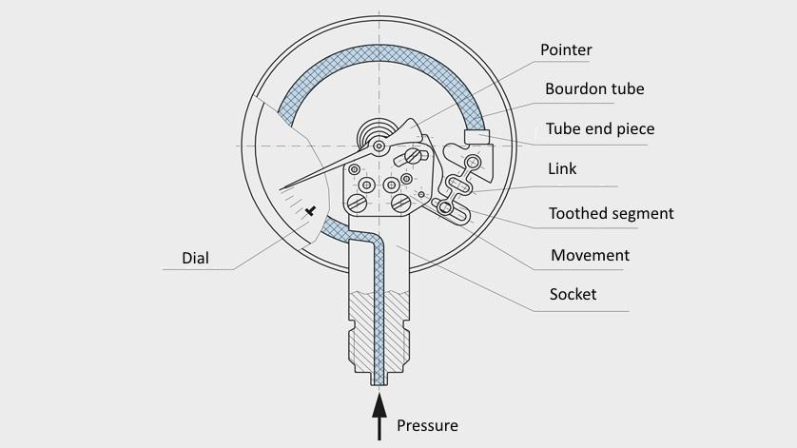
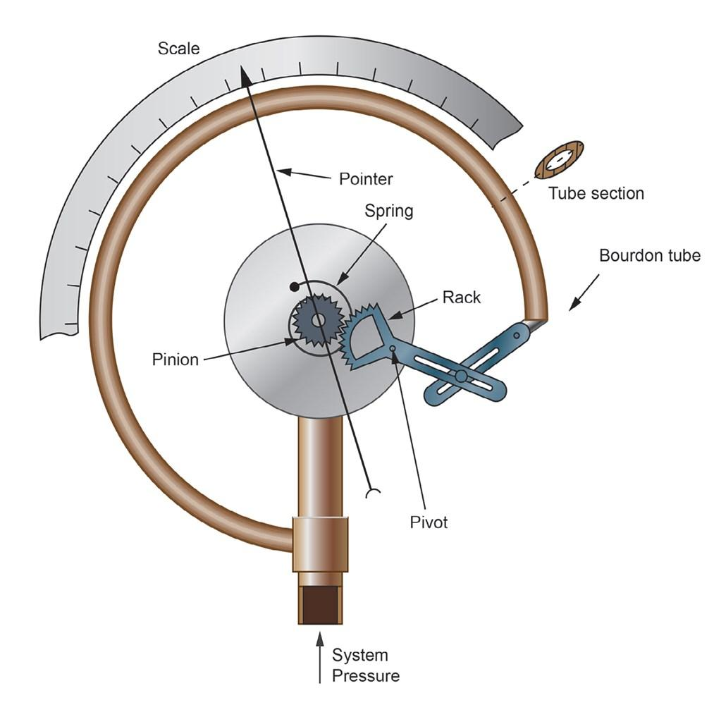
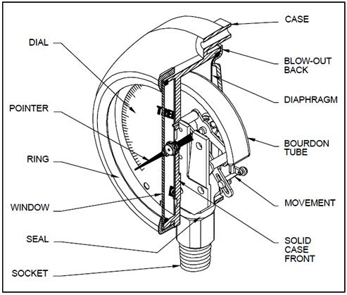
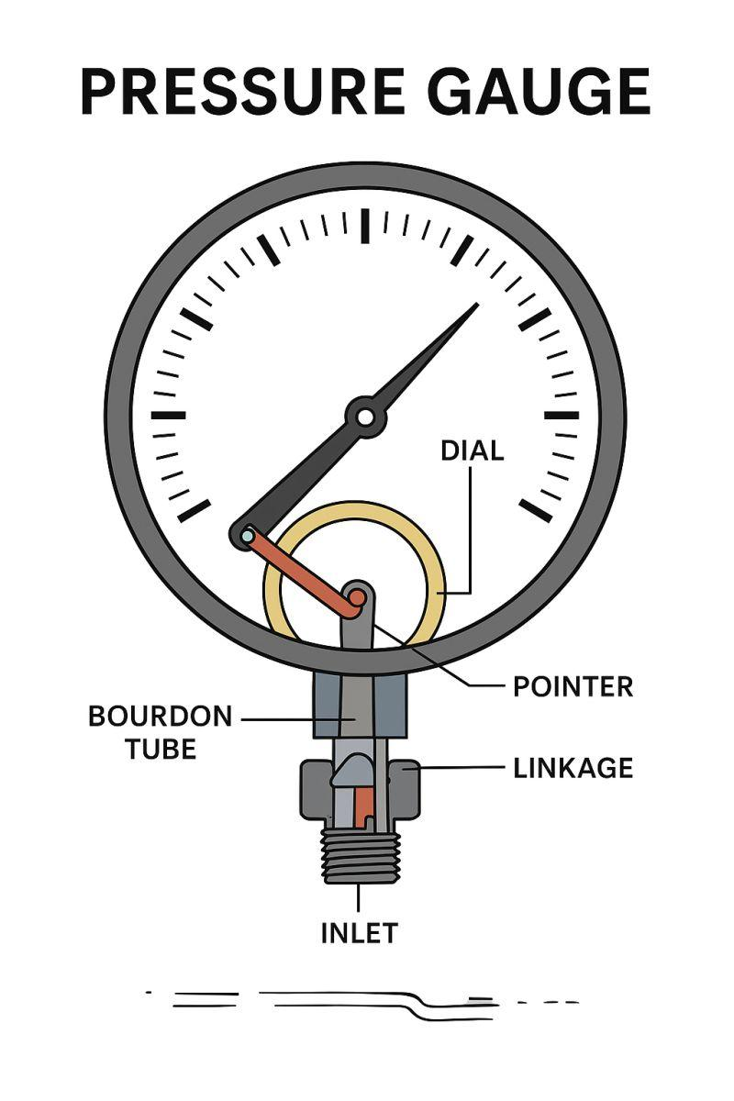
A typical pressure gauge consists of:
- Pressure sensing element
- Dial or digital display
- Pointer (analog gauges)
- Housing
- Pressure connection
- Protective window

Types of Pressure Gauges

1. Bourdon Tube Pressure Gauge
# Source: AI Source: Provided by: [Data Path: Persons Table -> ID Column: 1, Name_En Column: Motasem Essam] -> From: [ChatGPT] on [7/17/2026]

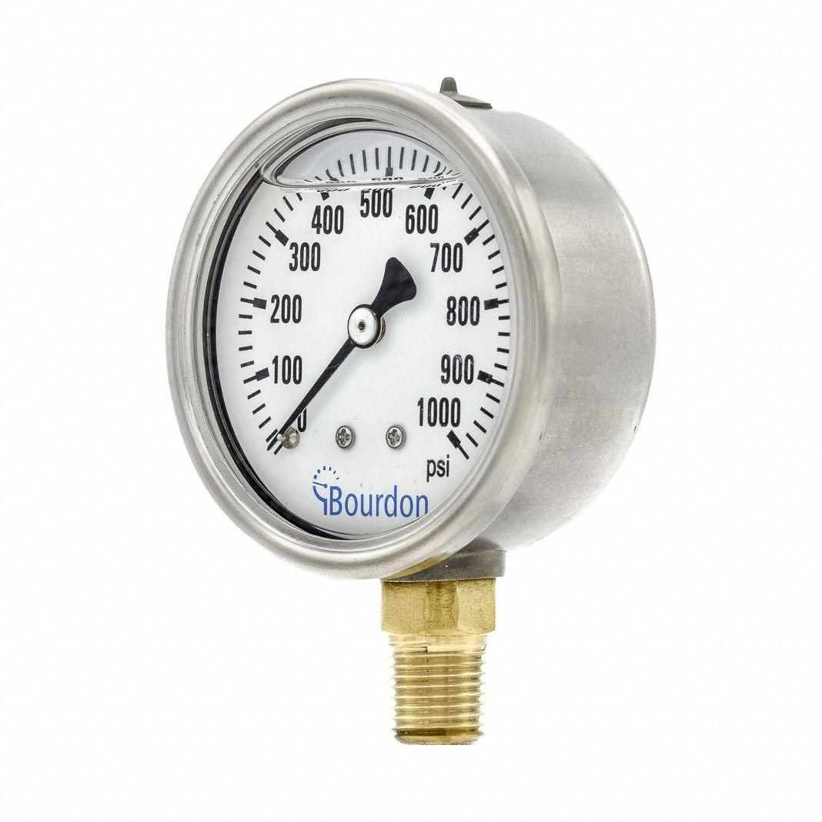
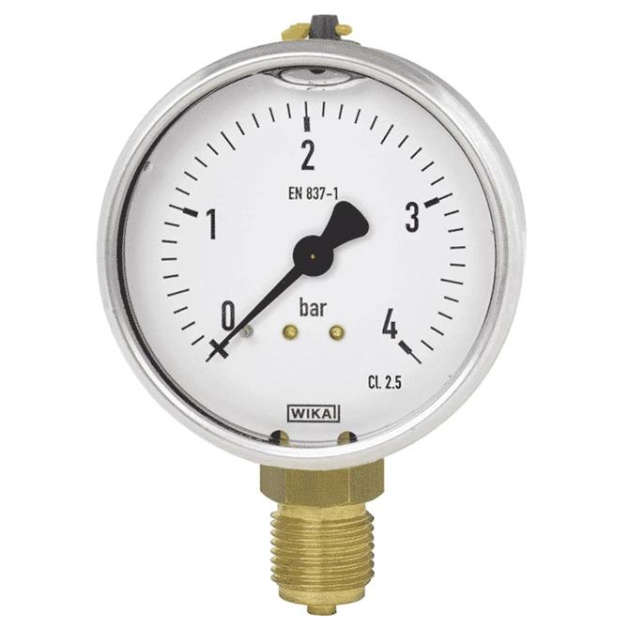
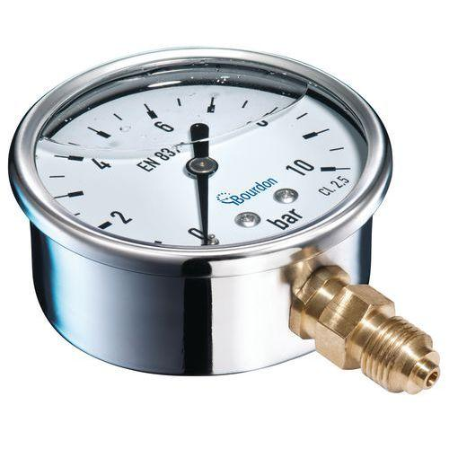
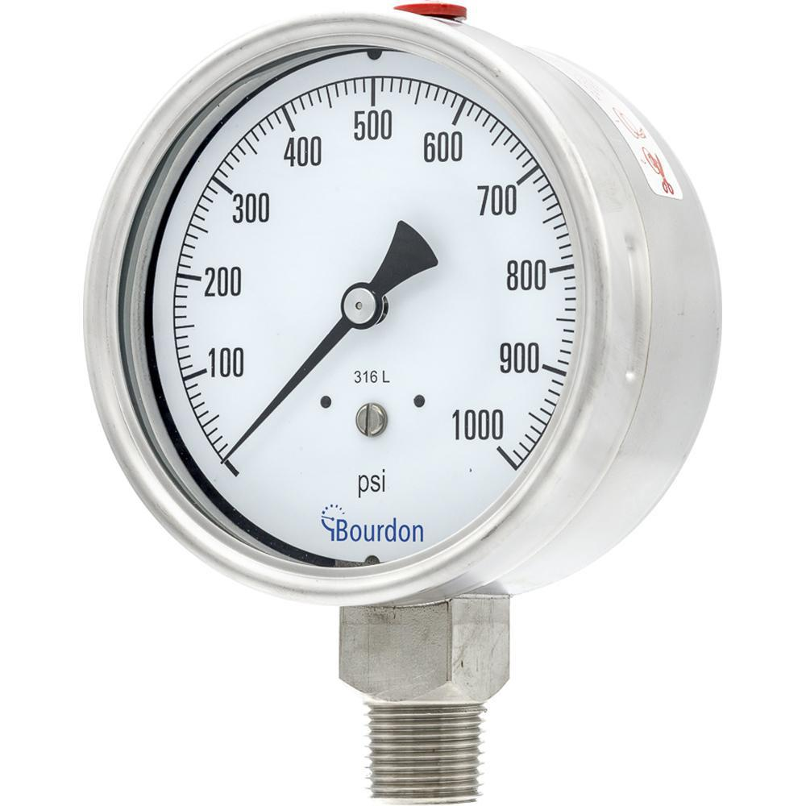
Description
Uses a curved metal tube (Bourdon tube) that straightens slightly when pressure increases.
Applications
- Hydraulic systems
- Compressors
- Boilers
- Industrial process control

2. Digital Pressure Gauge
# Source: AI Source: Provided by: [Data Path: Persons Table -> ID Column: 1, Name_En Column: Motasem Essam] -> From: [ChatGPT] on [7/17/2026]

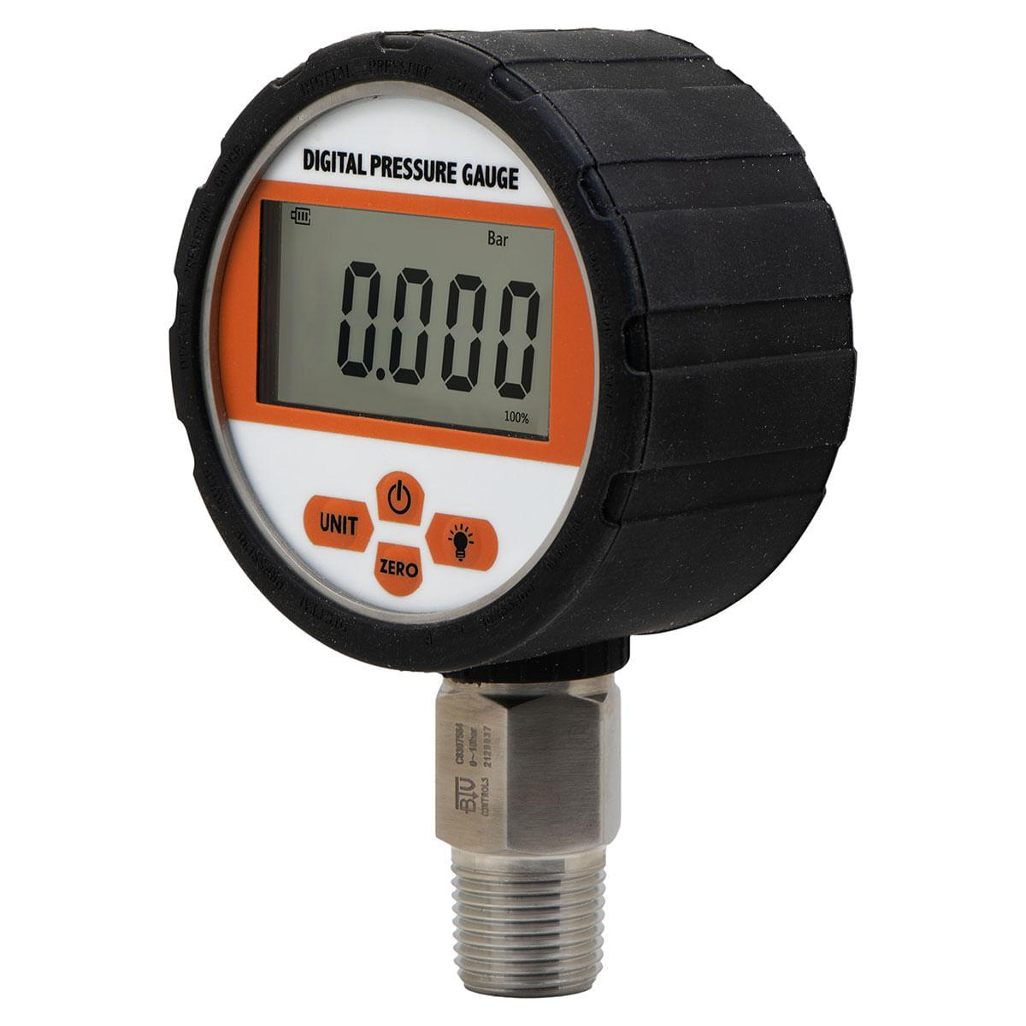
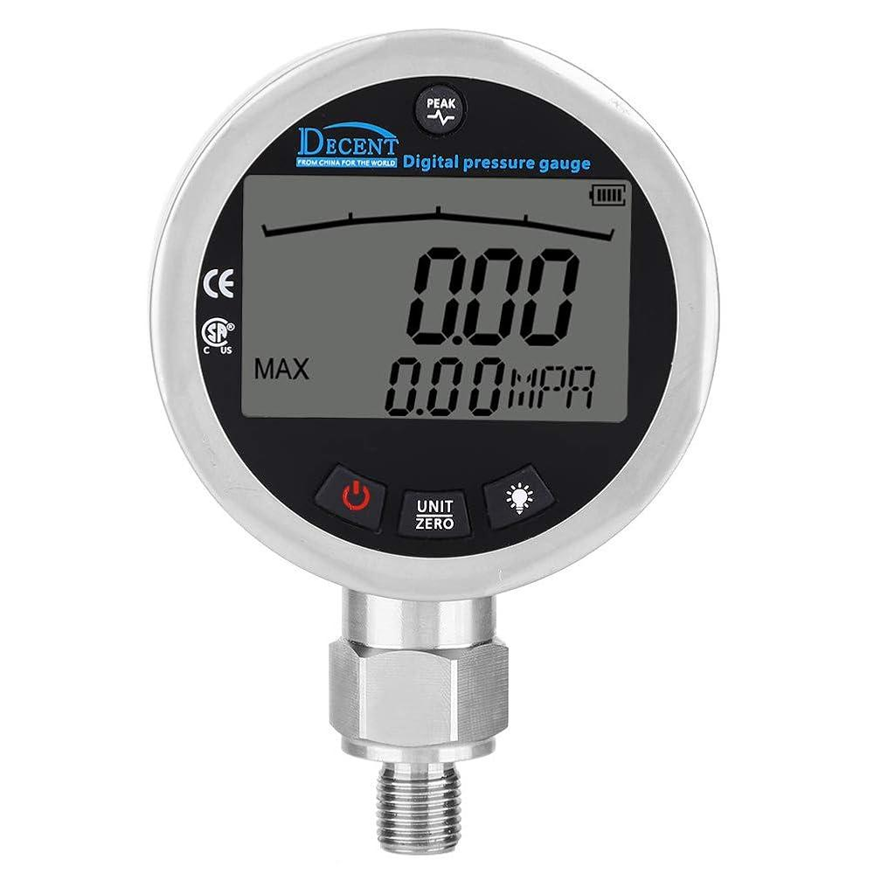
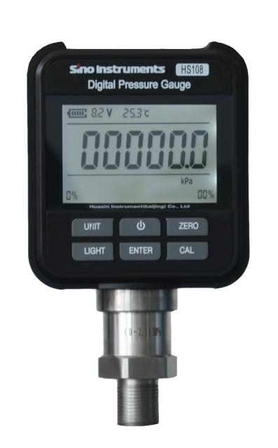
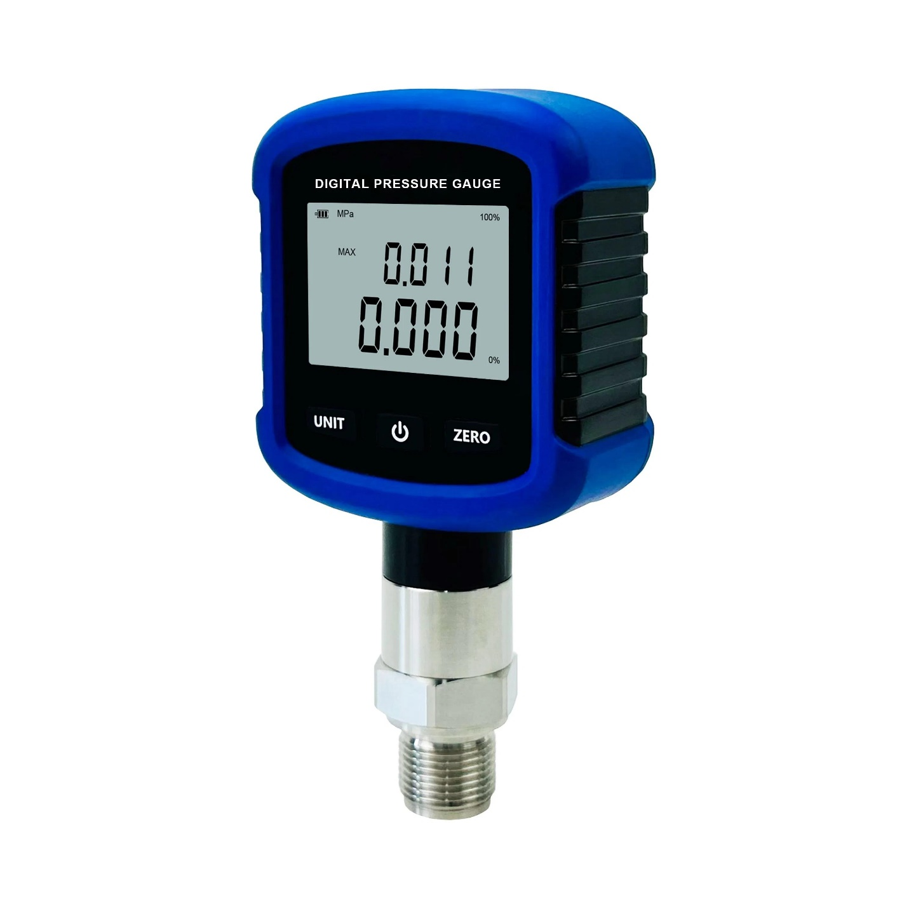
Description
Uses an electronic pressure sensor with a digital display for high-accuracy pressure measurement.
Applications
- Calibration laboratories
- Industrial automation
- Research
- Quality control

3. Differential Pressure Gauge
# Source: AI Source: Provided by: [Data Path: Persons Table -> ID Column: 1, Name_En Column: Motasem Essam] -> From: [ChatGPT] on [7/17/2026]

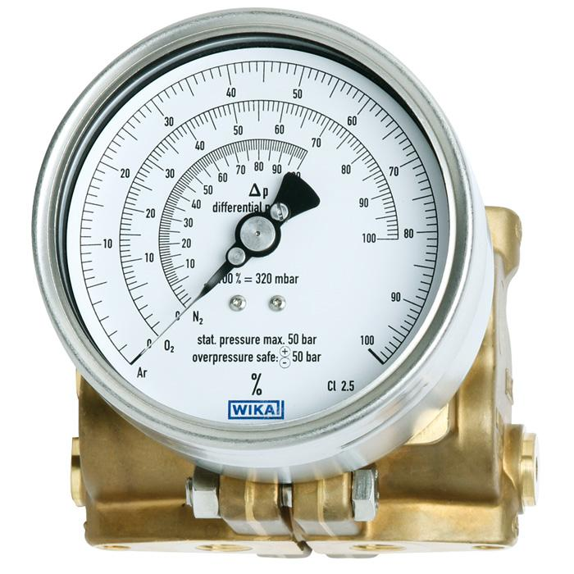
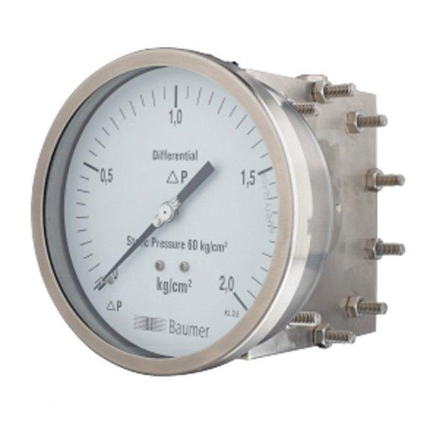
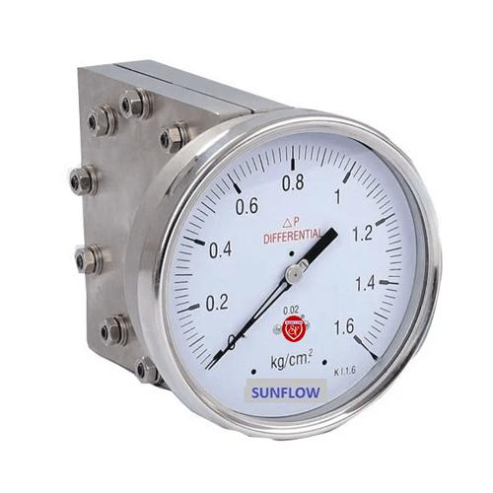
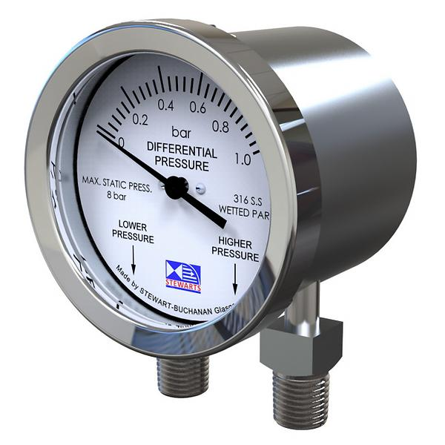
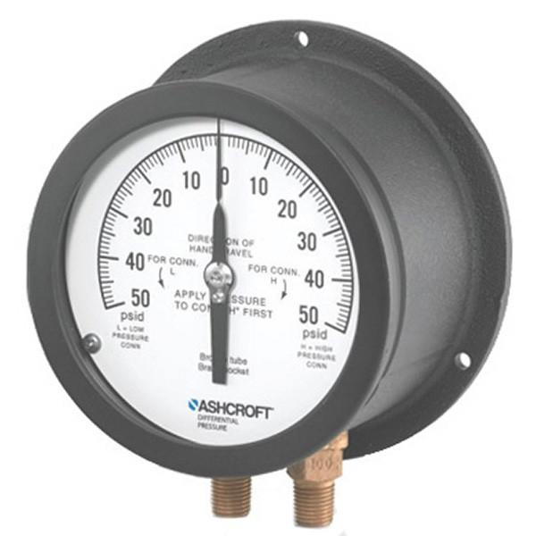
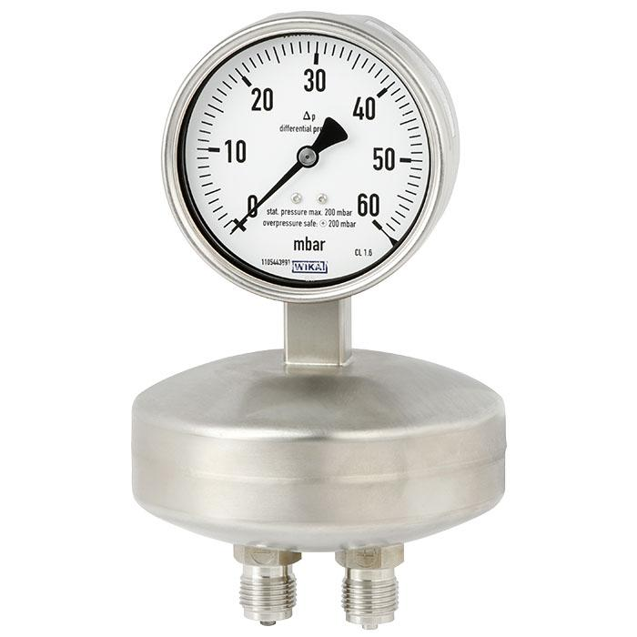
Description
Measures the pressure difference between two separate pressure points.
Applications
- HVAC systems
- Filter monitoring
- Flow measurement
- Clean rooms

4. Vacuum Pressure Gauge
# Source: AI Source: Provided by: [Data Path: Persons Table -> ID Column: 1, Name_En Column: Motasem Essam] -> From: [ChatGPT] on [7/17/2026]

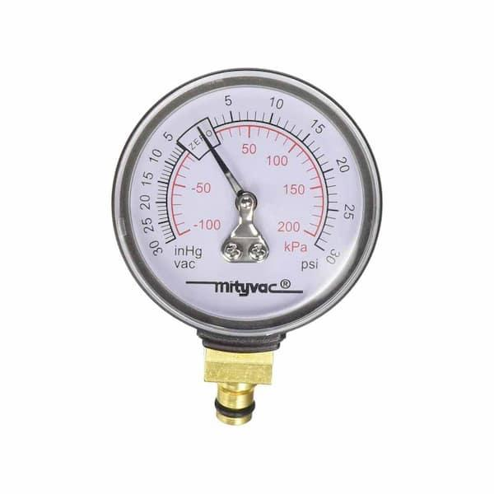
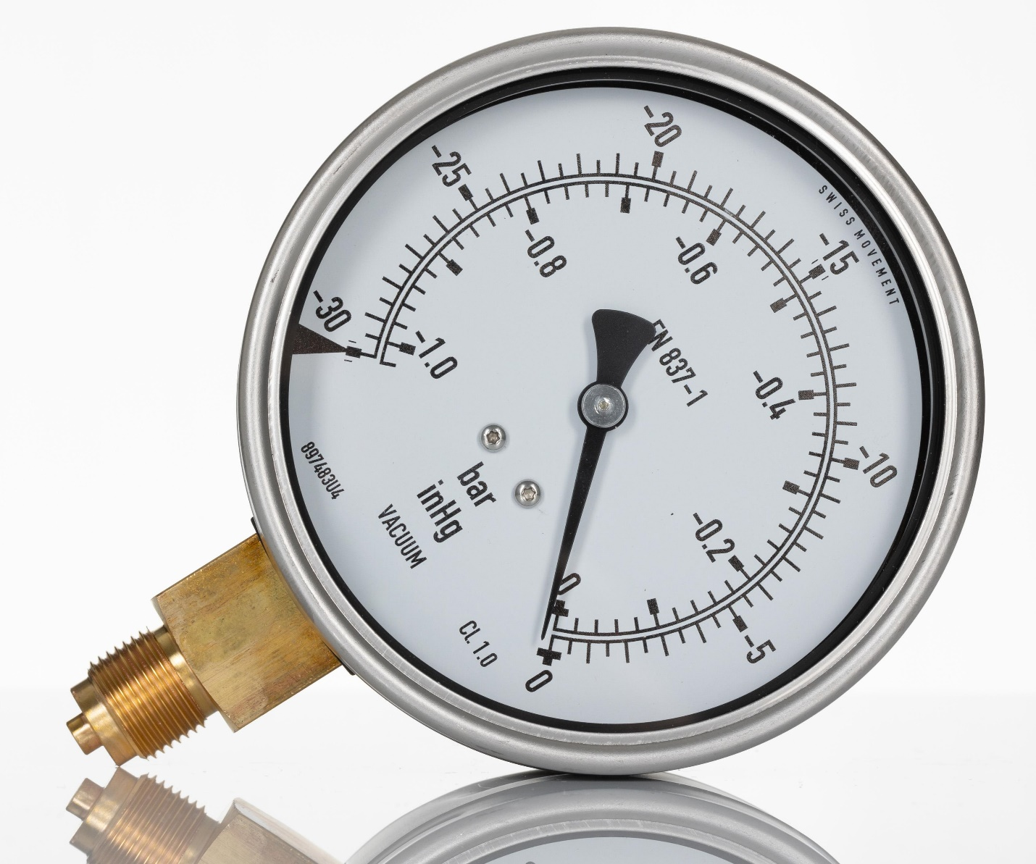
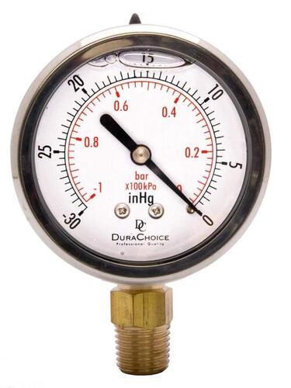
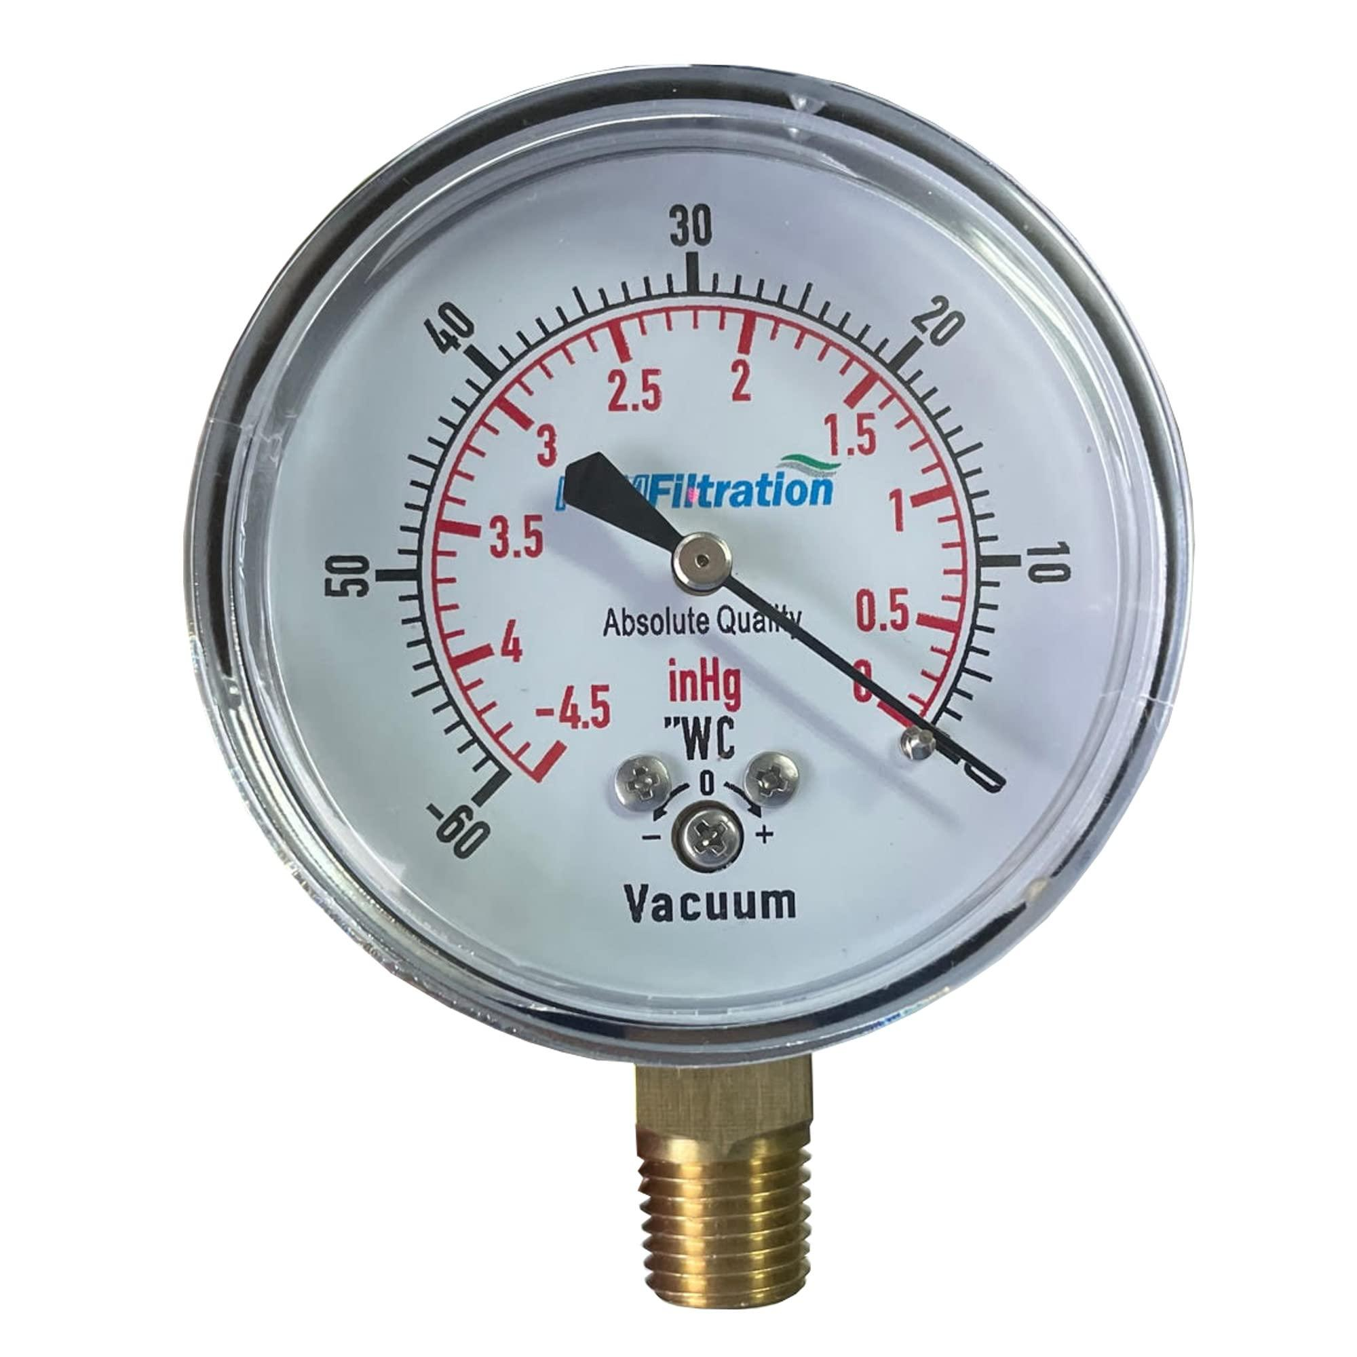
Description
Measures pressures below atmospheric pressure (vacuum).
Applications
- Vacuum pumps
- Refrigeration
- Laboratories
- Vacuum processing

5. Compound Pressure Gauge
# Source: AI Source: Provided by: [Data Path: Persons Table -> ID Column: 1, Name_En Column: Motasem Essam] -> From: [ChatGPT] on [7/17/2026]
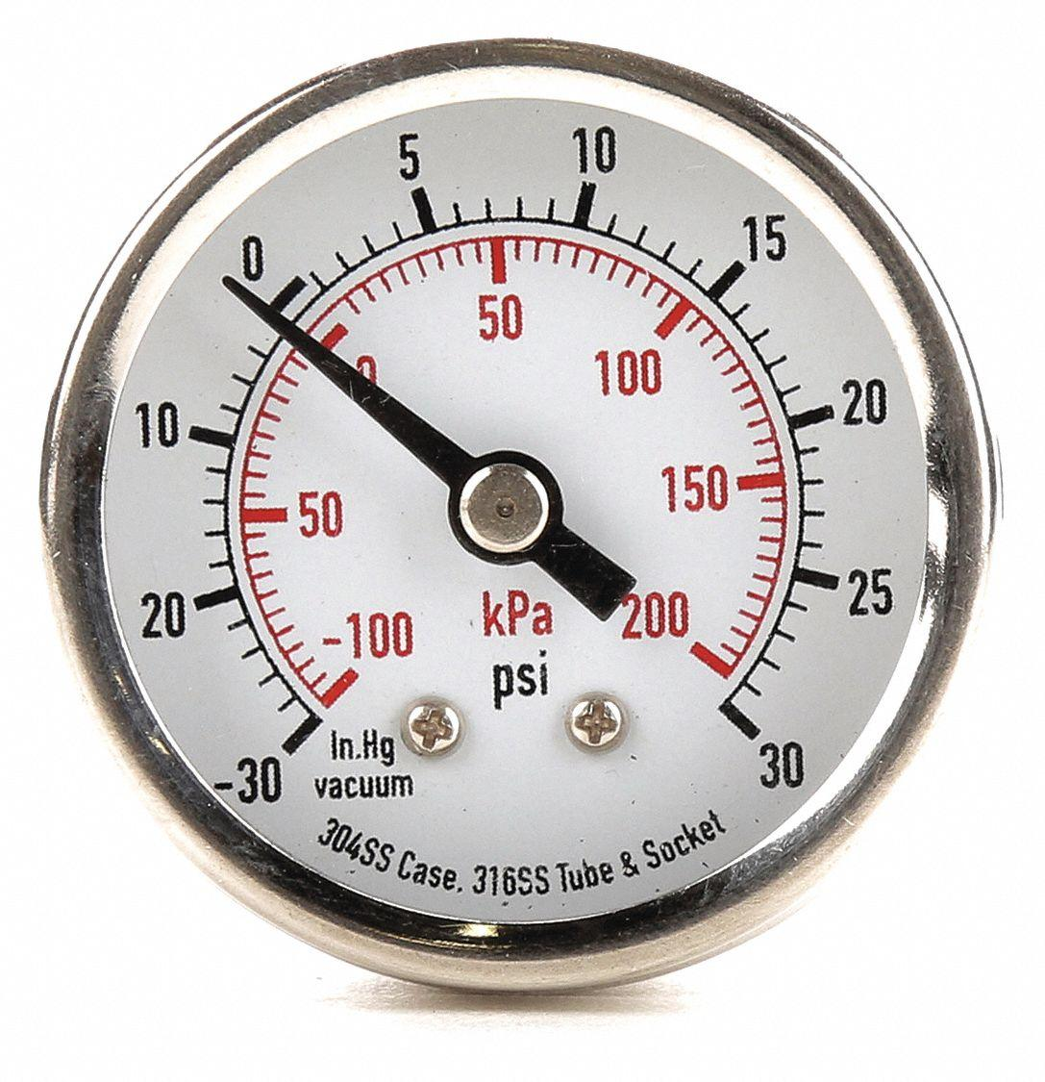
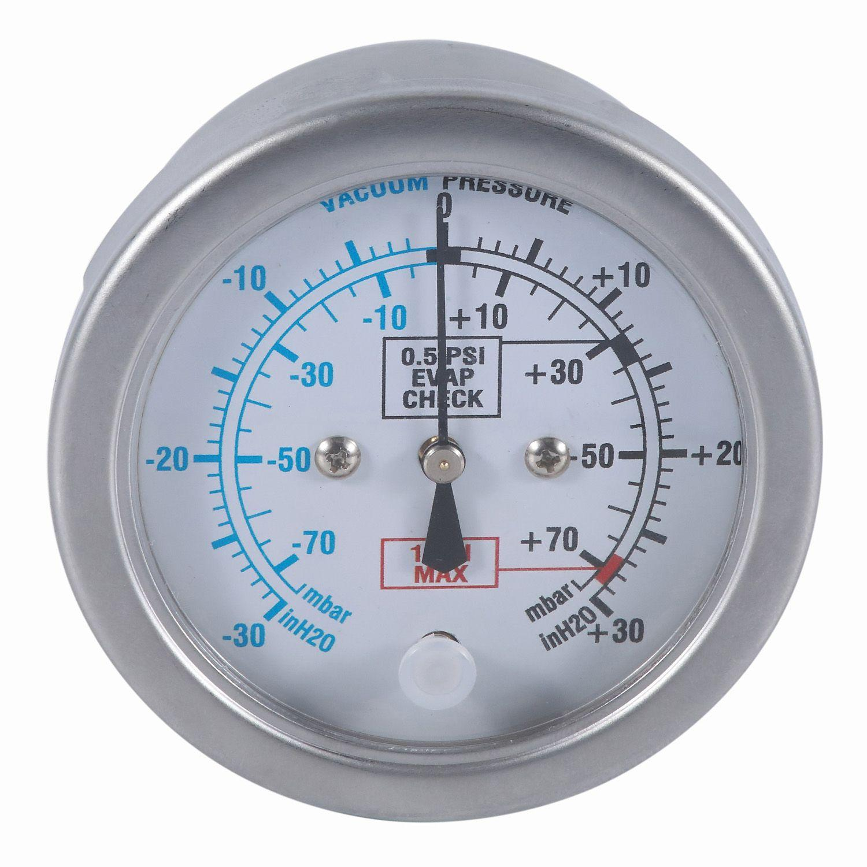
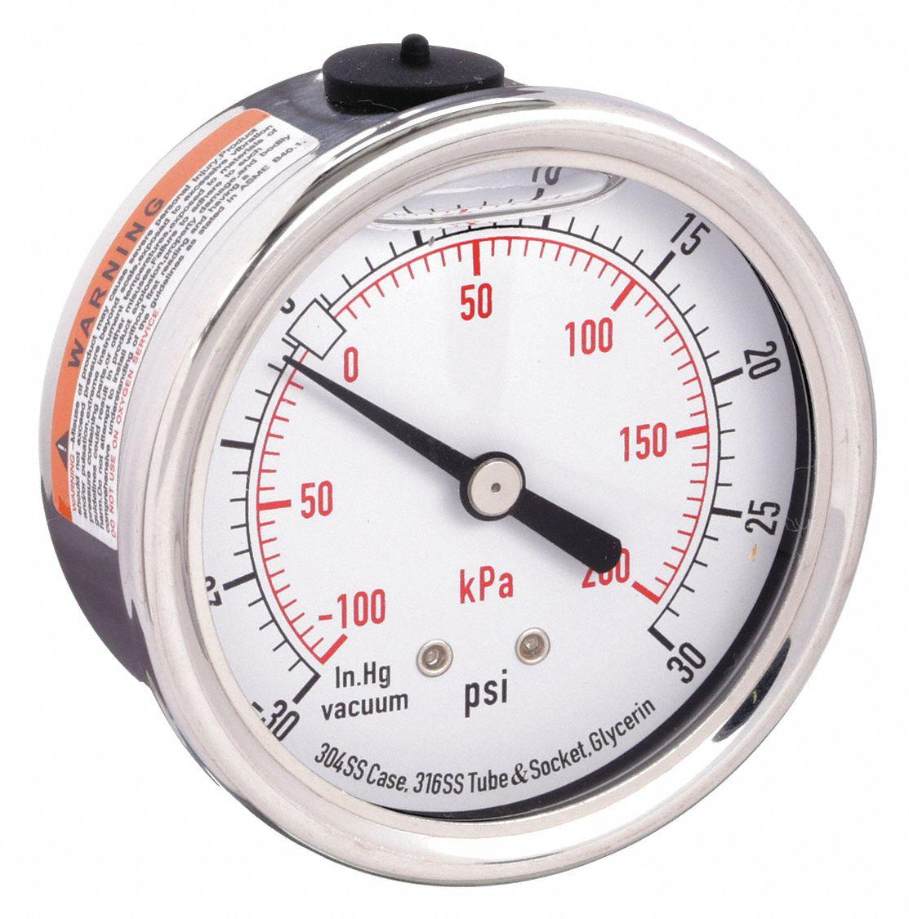
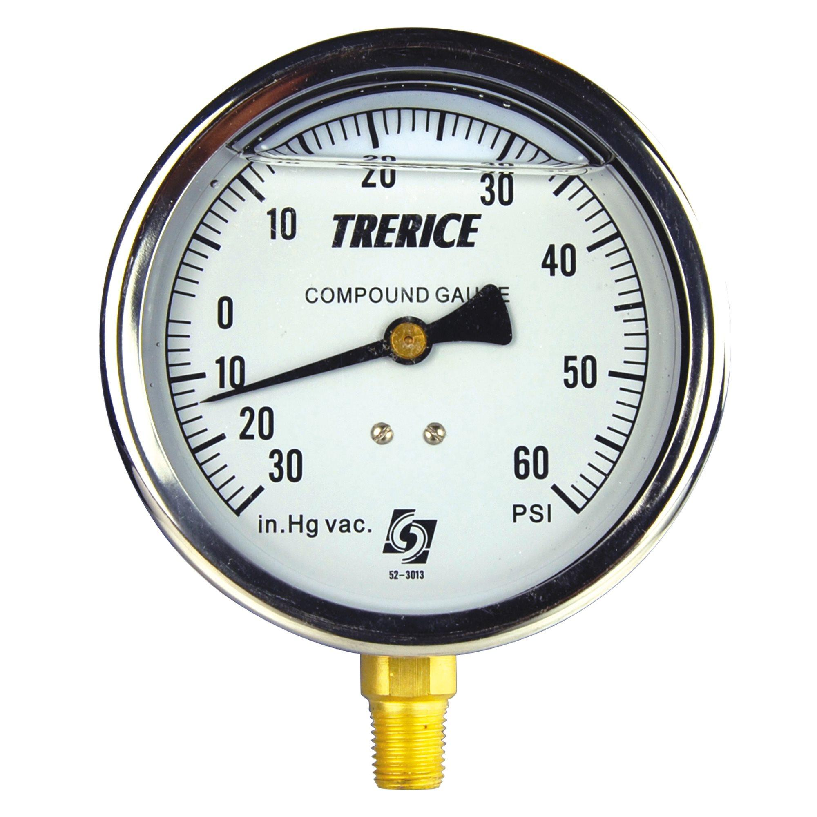
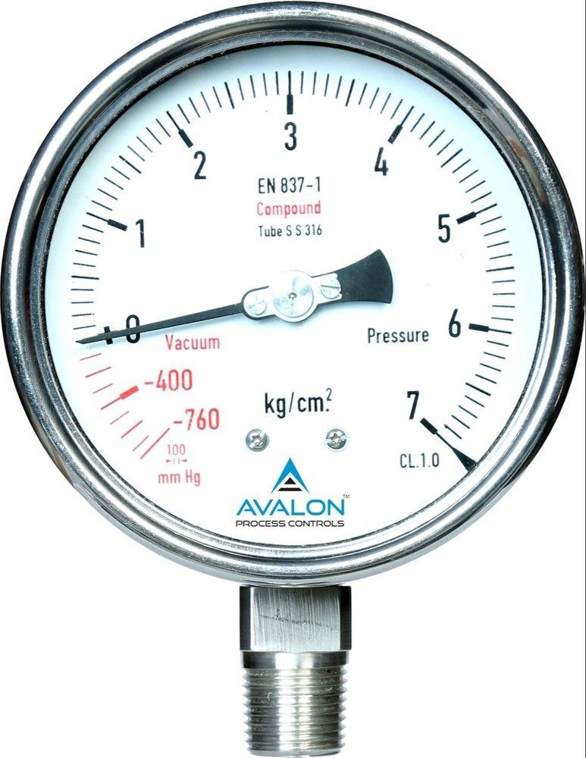
Description
Measures both vacuum pressure and positive pressure using a single instrument.
Applications
- Refrigeration
- Air-conditioning
- Hydraulic systems
- Pneumatic systems

6. Diaphragm Pressure Gauge
# Source: AI Source: Provided by: [Data Path: Persons Table -> ID Column: 1, Name_En Column: Motasem Essam] -> From: [ChatGPT] on [7/17/2026]
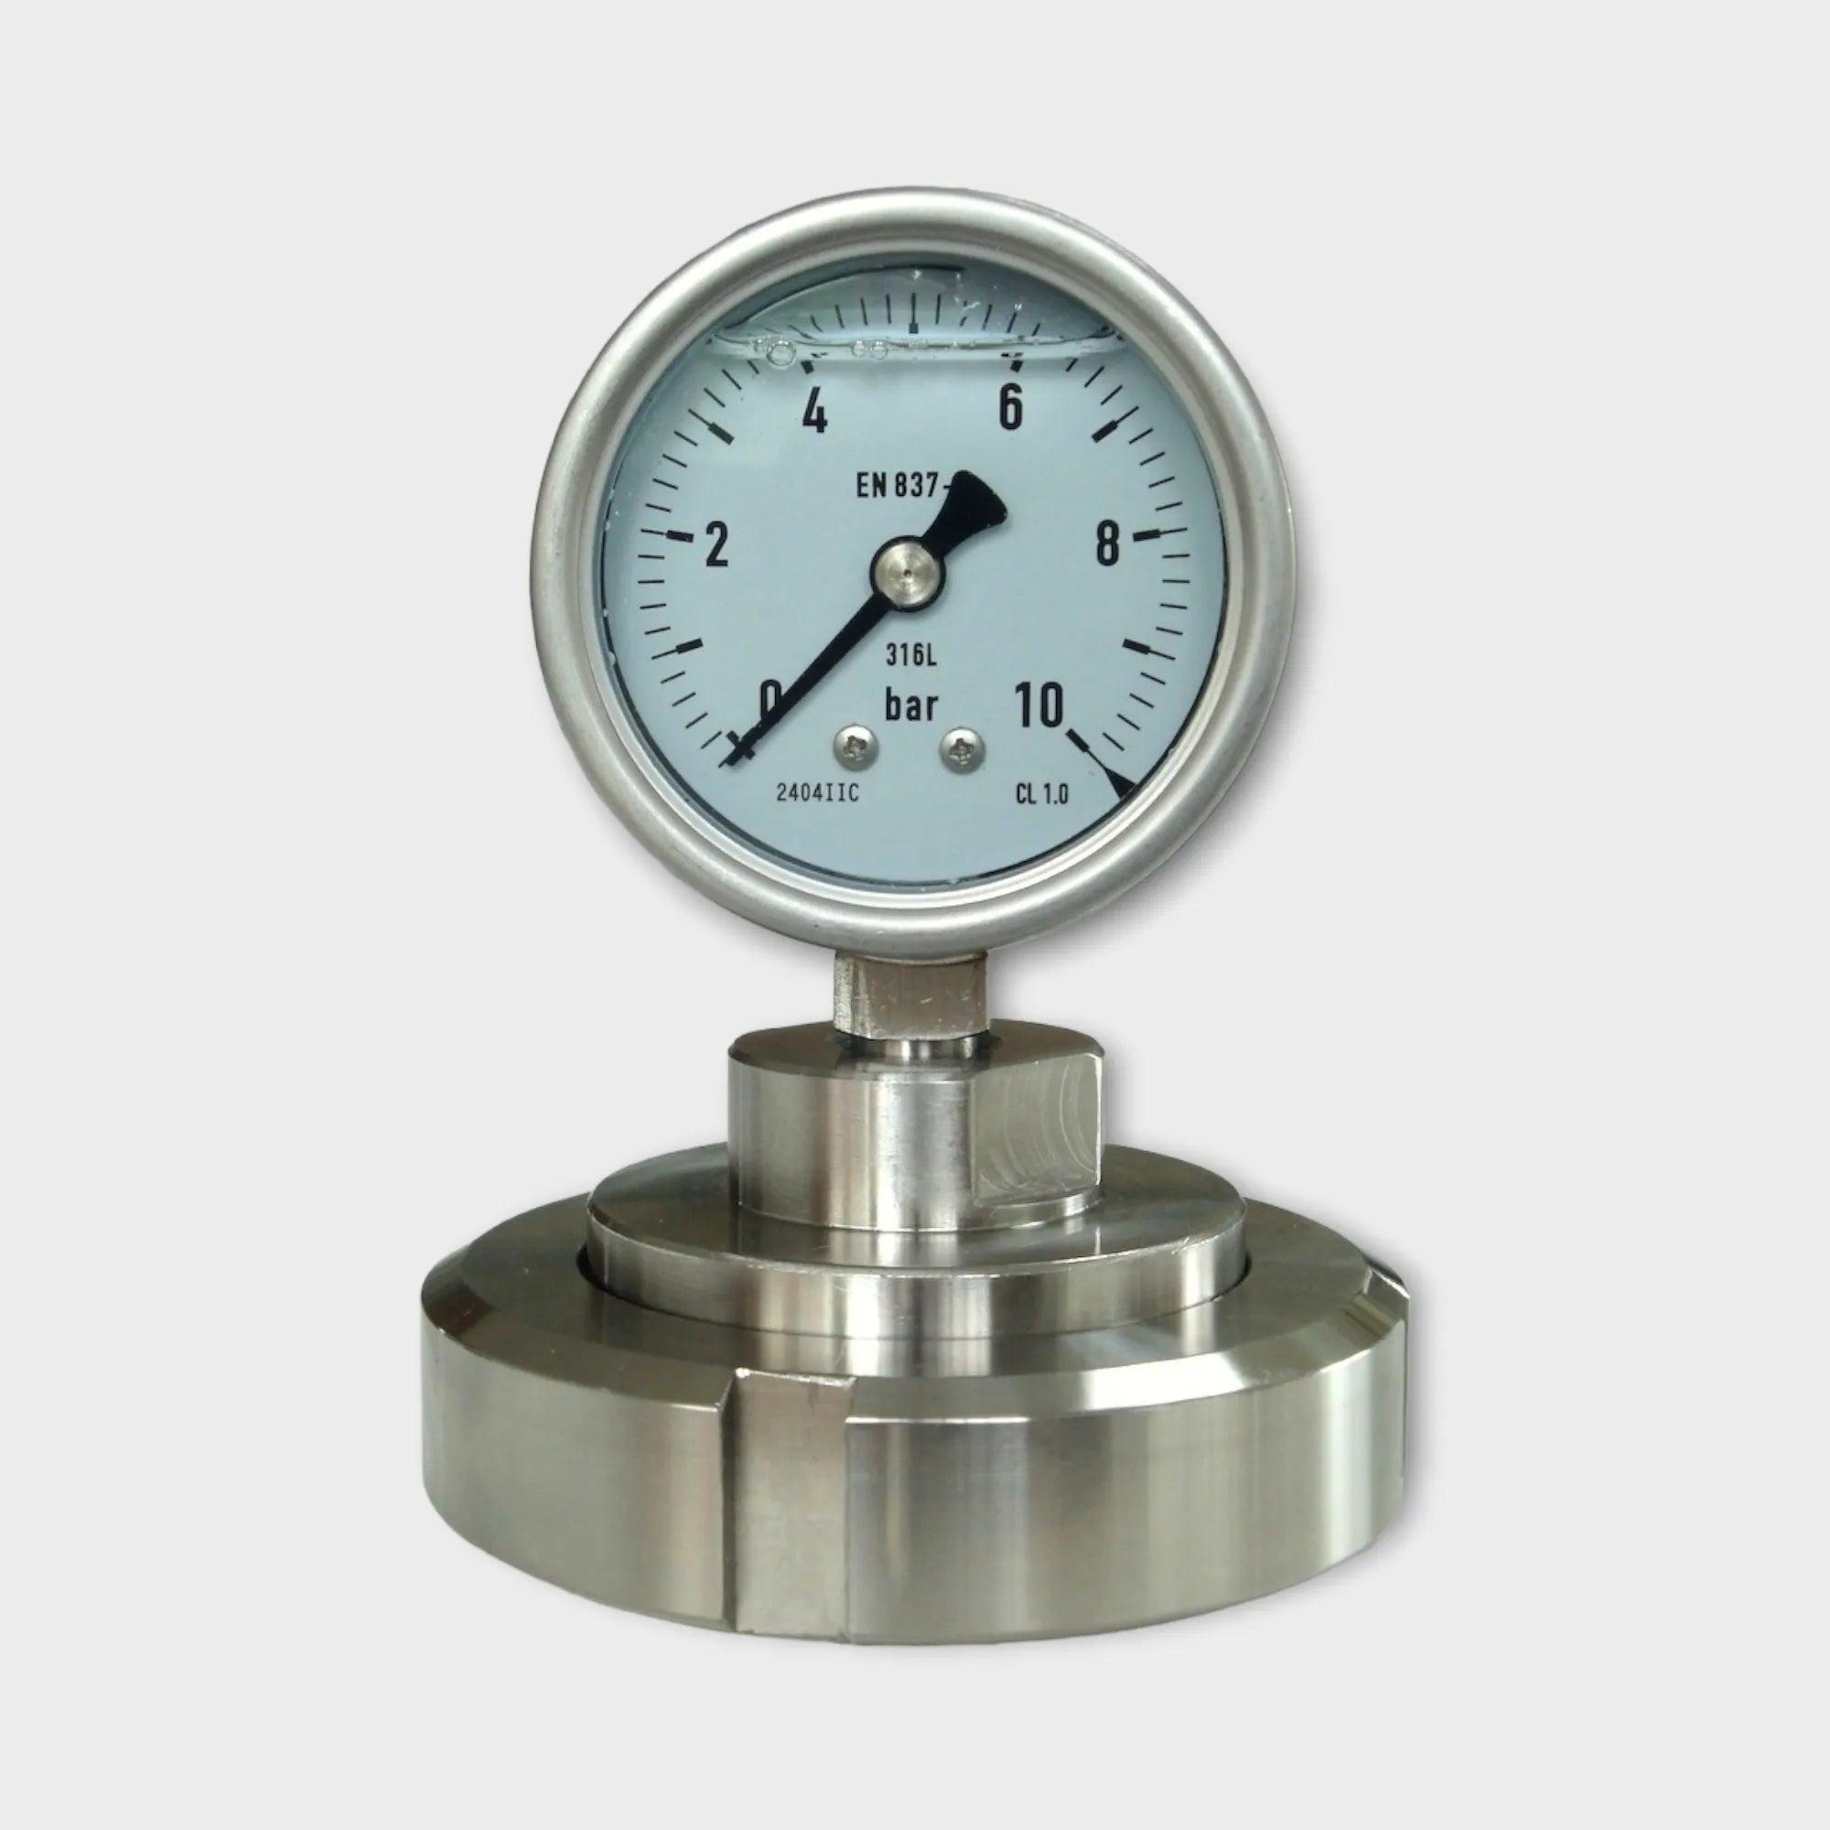
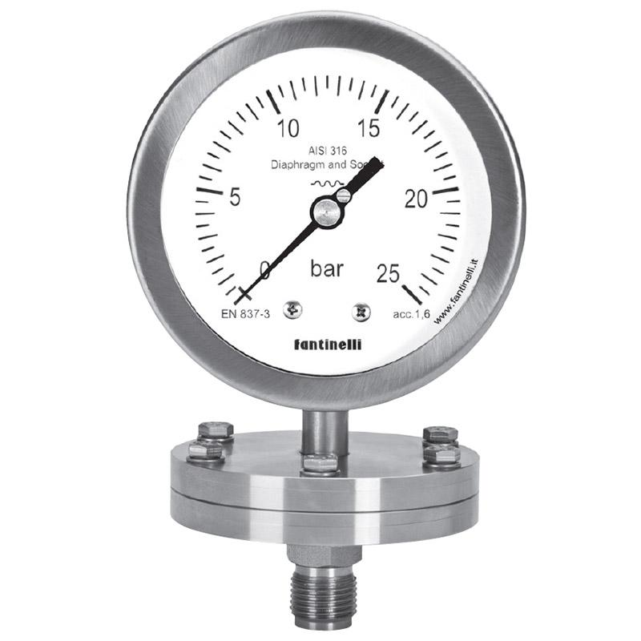
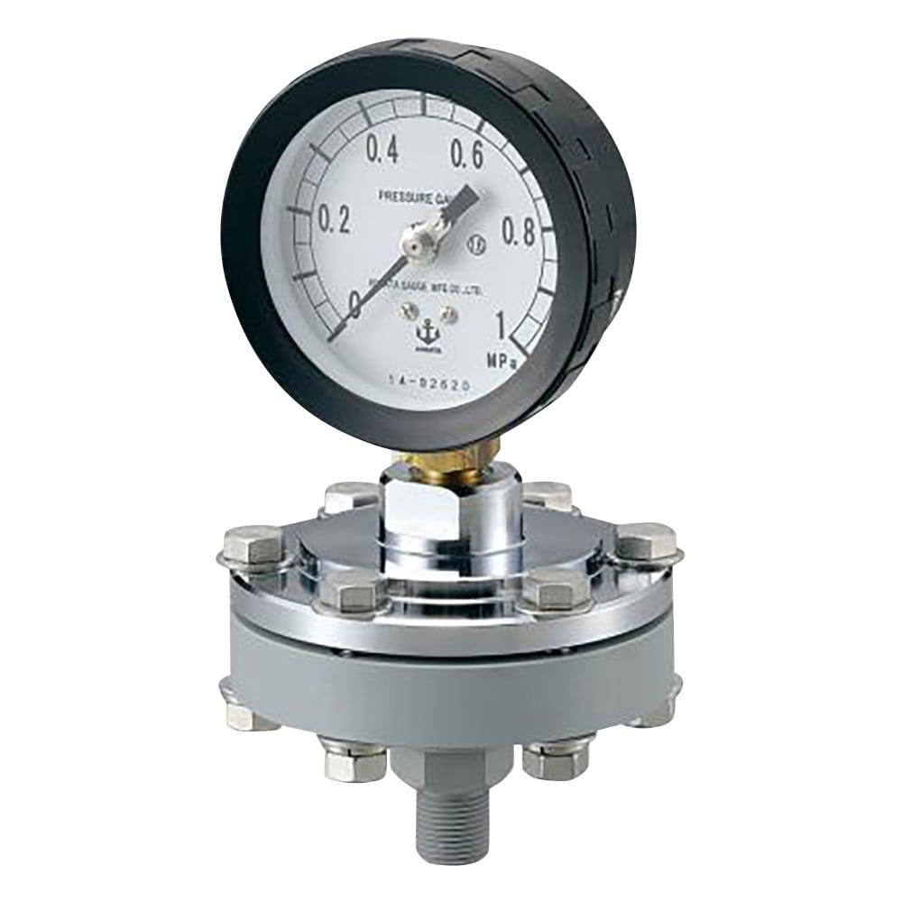
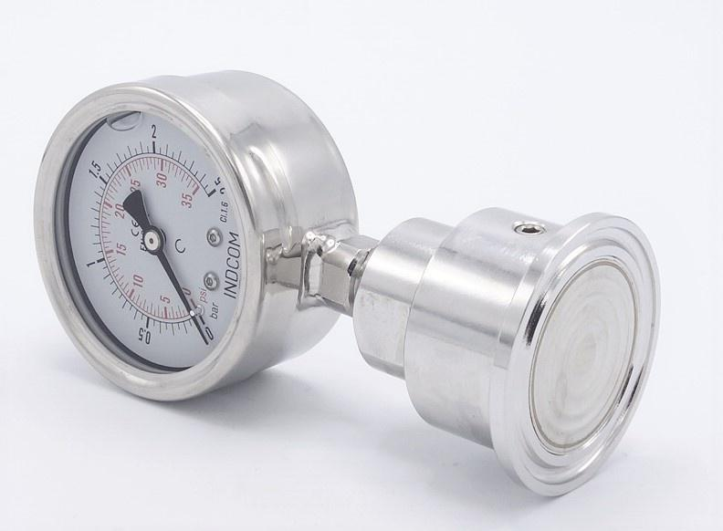
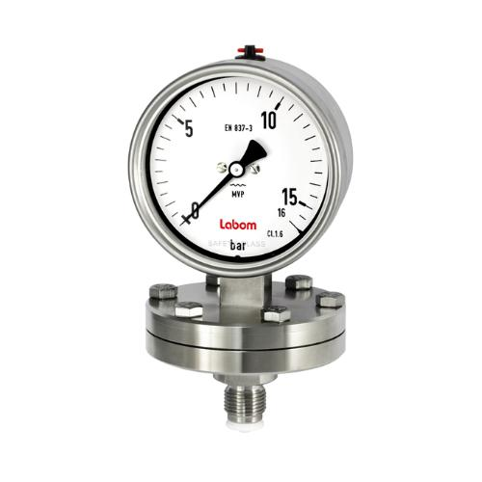
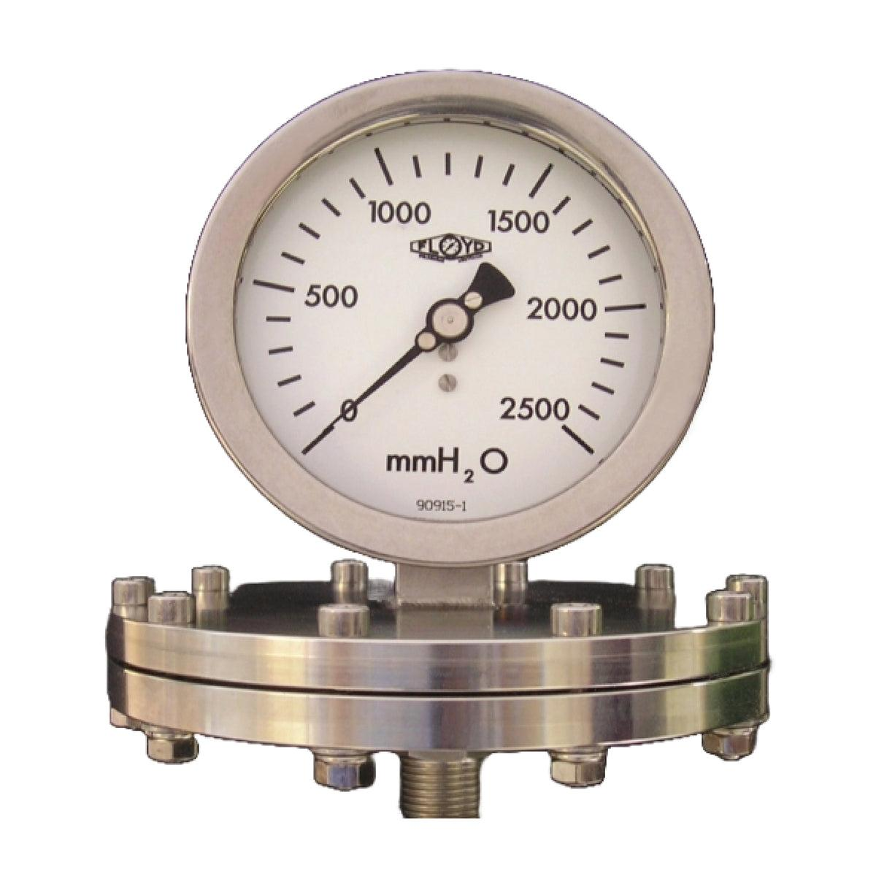
Description
Uses a flexible diaphragm as the pressure-sensing element, making it suitable for low pressures and corrosive or contaminated fluids.
Applications
- Chemical processing
- Pharmaceutical industry
- Food and beverage industry
- Low-pressure measurement

7. Capsule Pressure Gauge
# Source: AI Source: Provided by: [Data Path: Persons Table -> ID Column: 1, Name_En Column: Motasem Essam] -> From: [ChatGPT] on [7/17/2026]
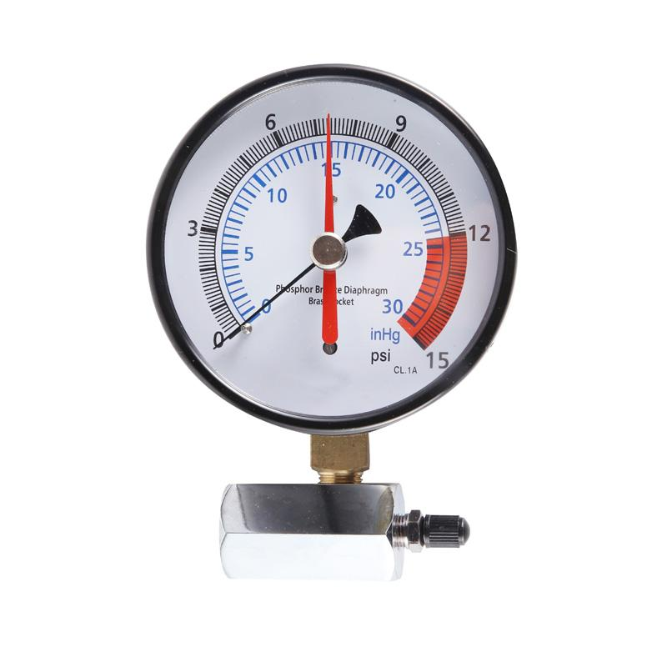
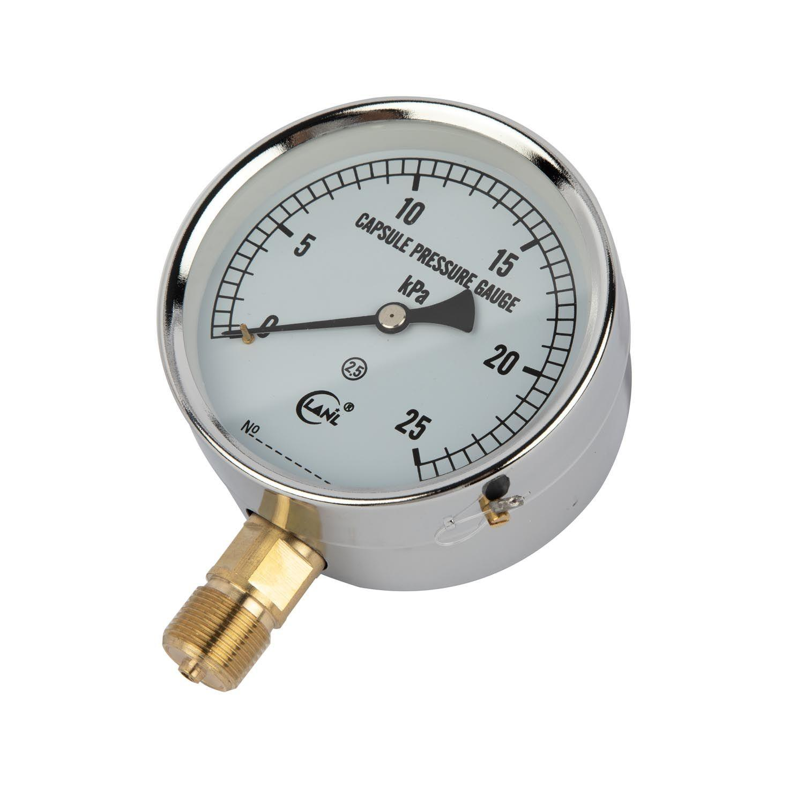
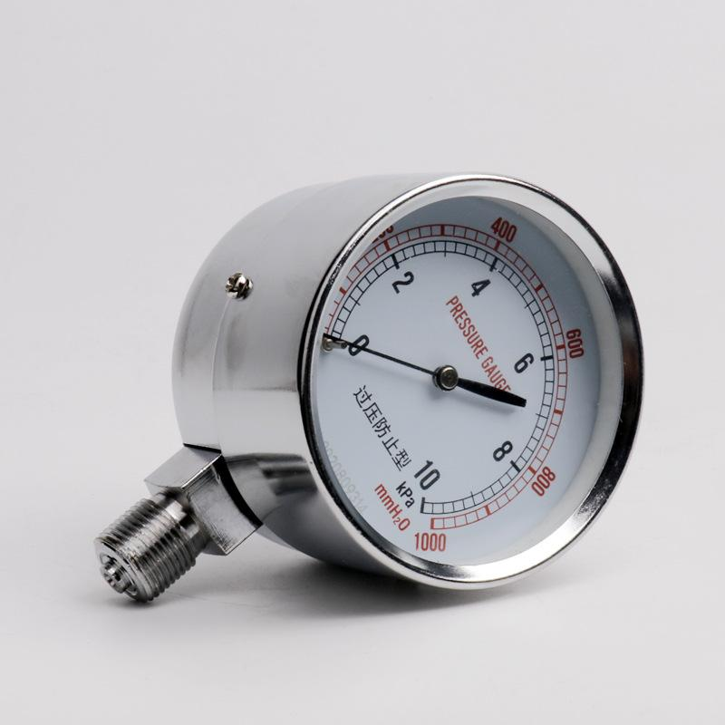
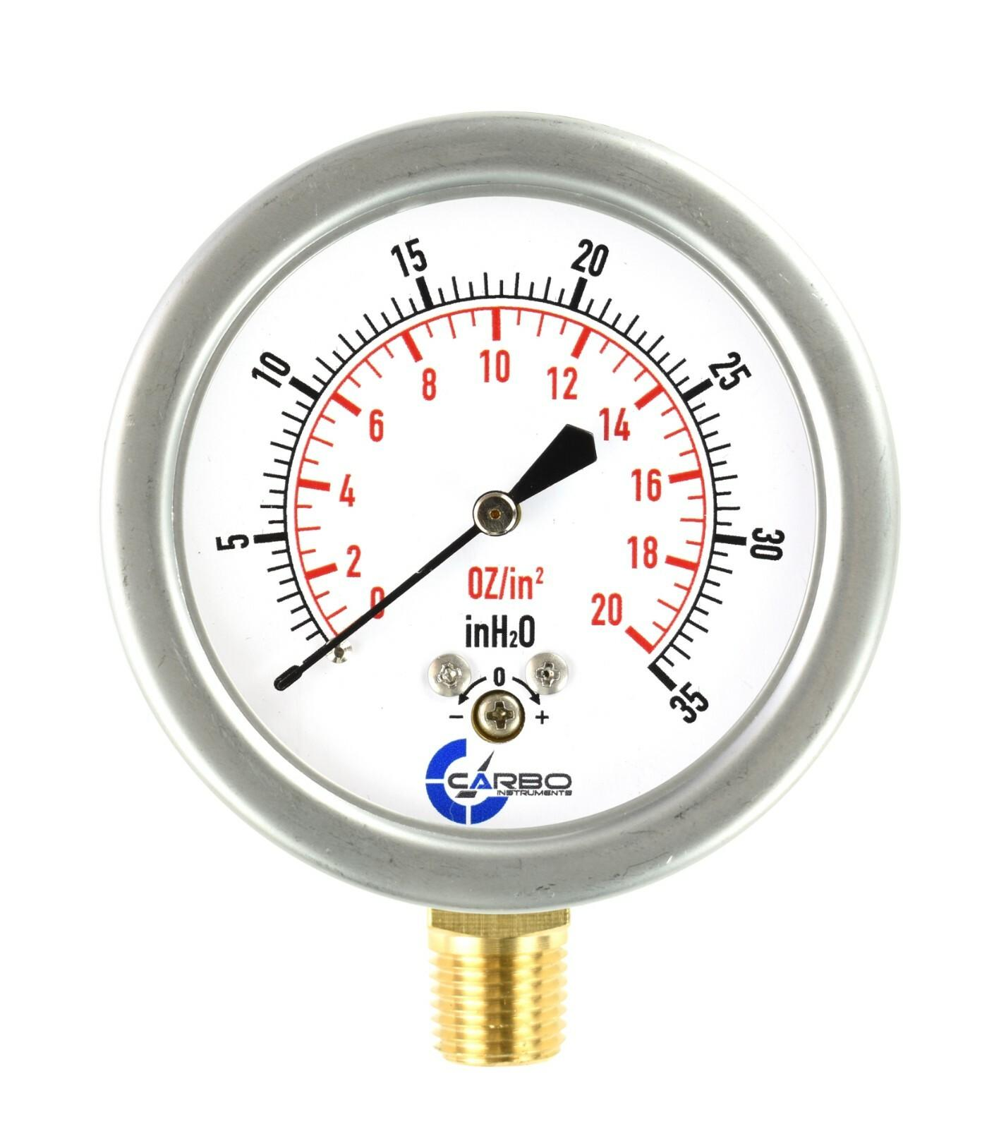
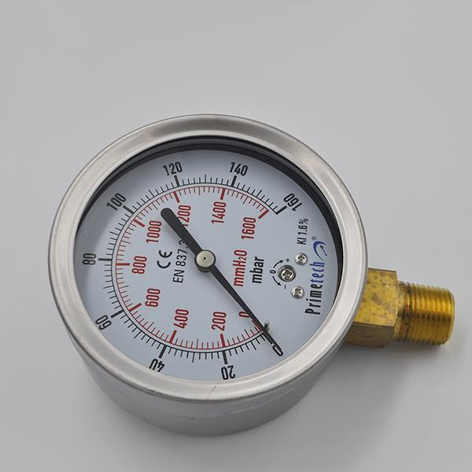
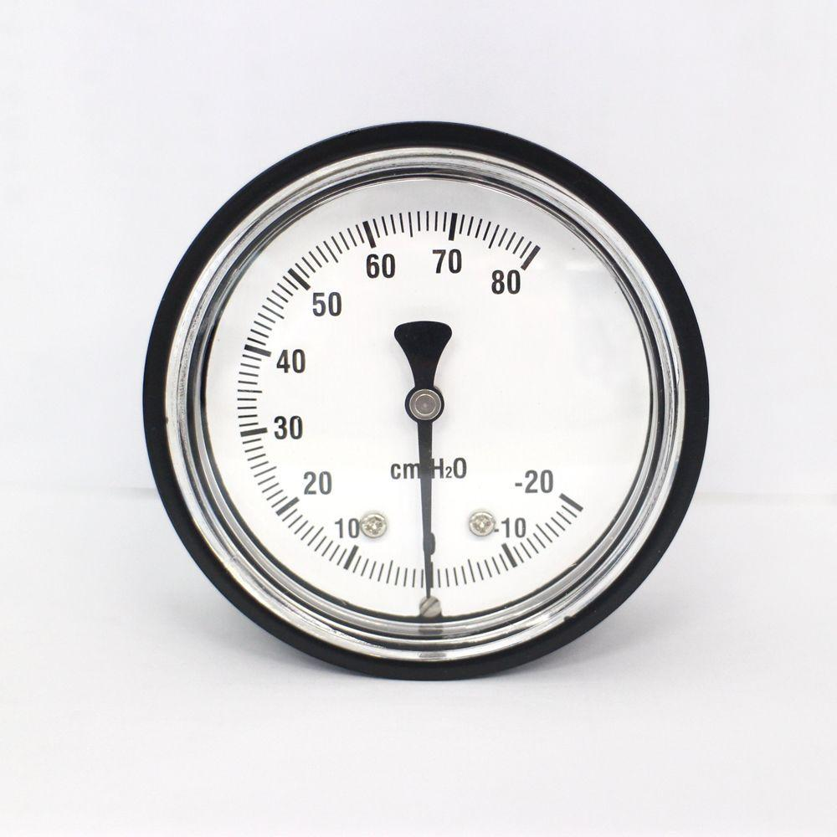
Description
Uses two thin diaphragms welded together to form a capsule that expands under very low pressure.
Applications
- Gas pressure measurement
- Ventilation systems
- Low-pressure process monitoring
- Laboratory equipment

8. Bellows Pressure Gauge
# Source: AI Source: Provided by: [Data Path: Persons Table -> ID Column: 1, Name_En Column: Motasem Essam] -> From: [ChatGPT] on [7/17/2026]
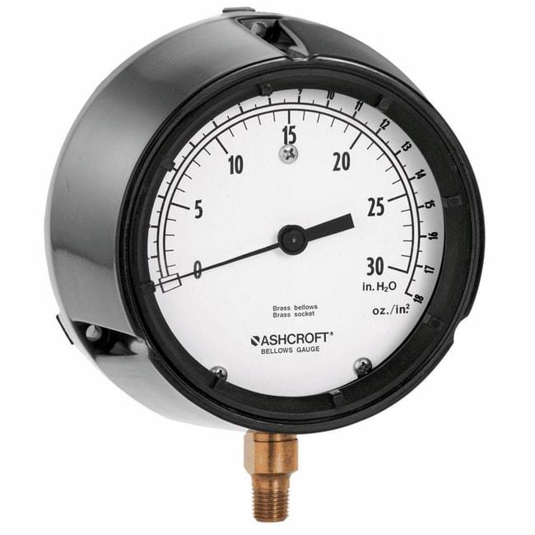
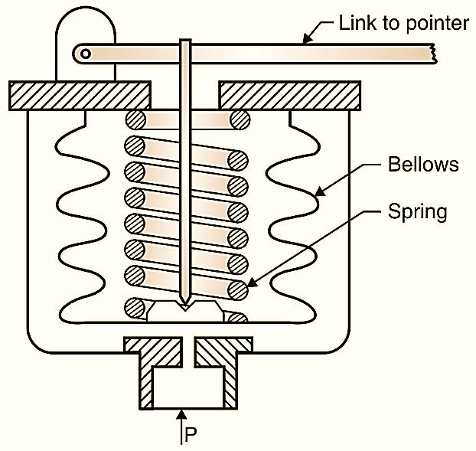
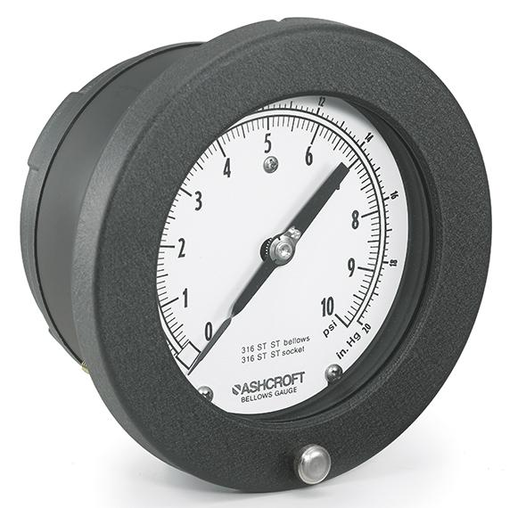
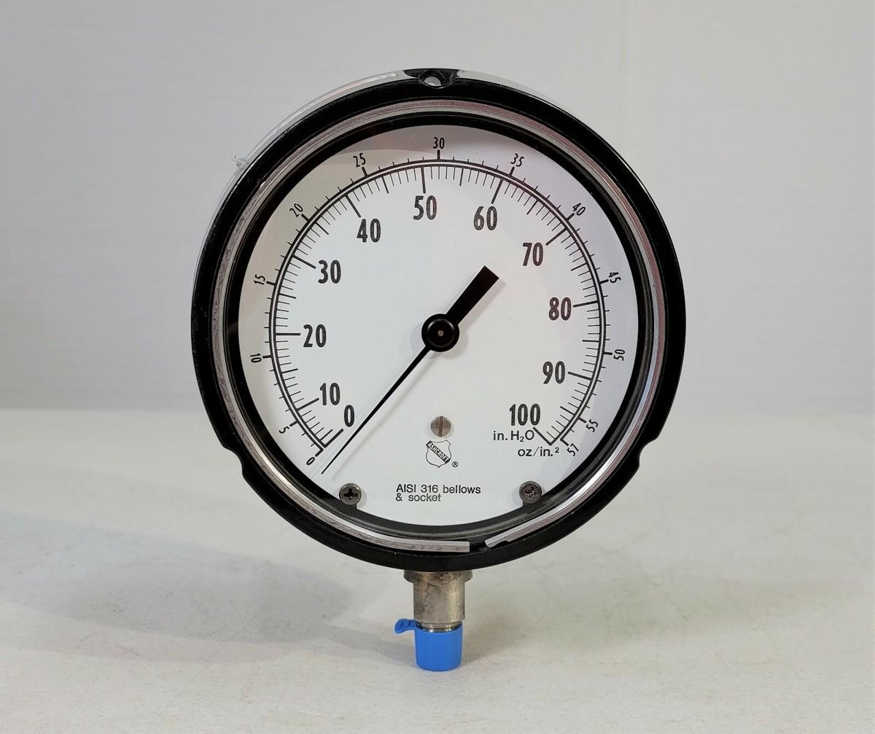
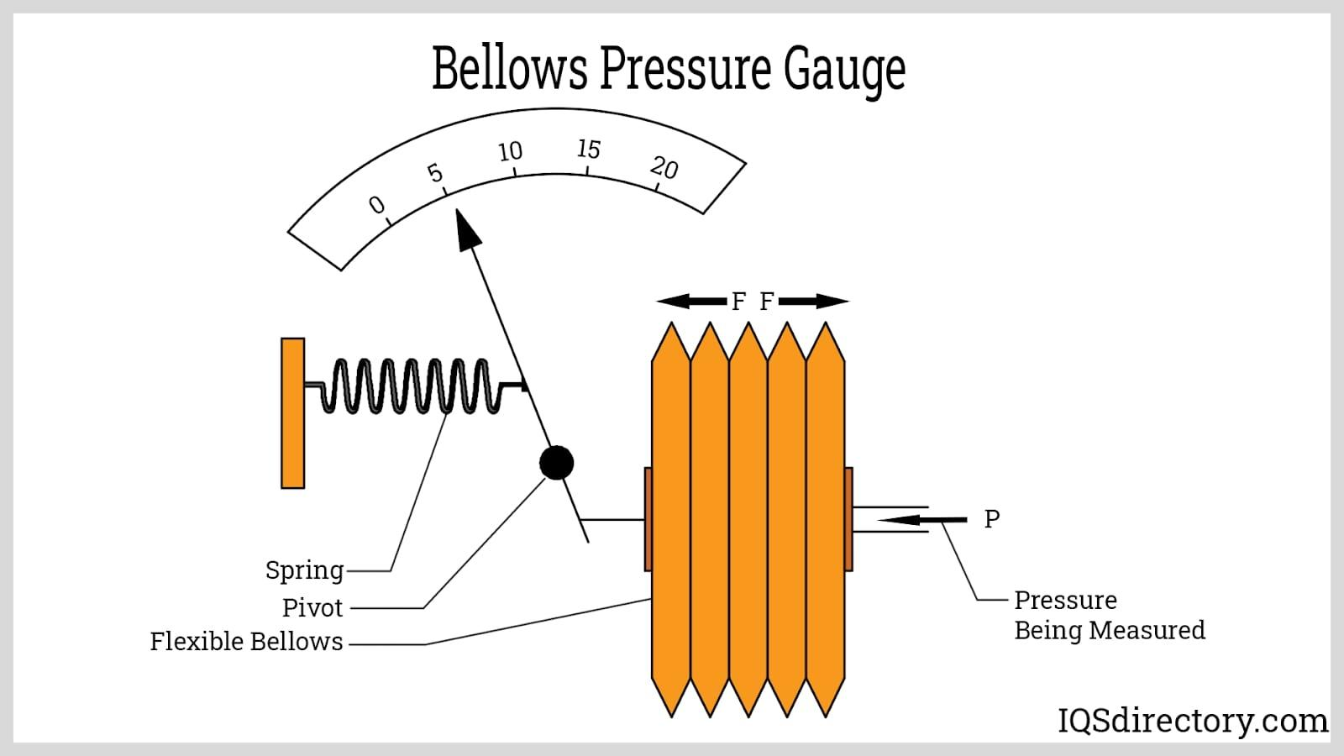
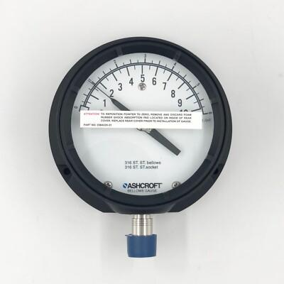
Description
Uses a flexible metallic bellows that expands or contracts in response to pressure changes.
Applications
- Low-pressure systems
- Vacuum systems
- Process instrumentation
- Pneumatic control systems

9. Tire Pressure Gauge
# Source: AI Source: Provided by: [Data Path: Persons Table -> ID Column: 1, Name_En Column: Motasem Essam] -> From: [ChatGPT] on [7/17/2026]
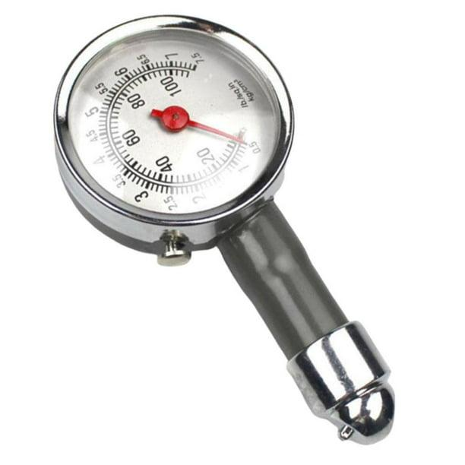
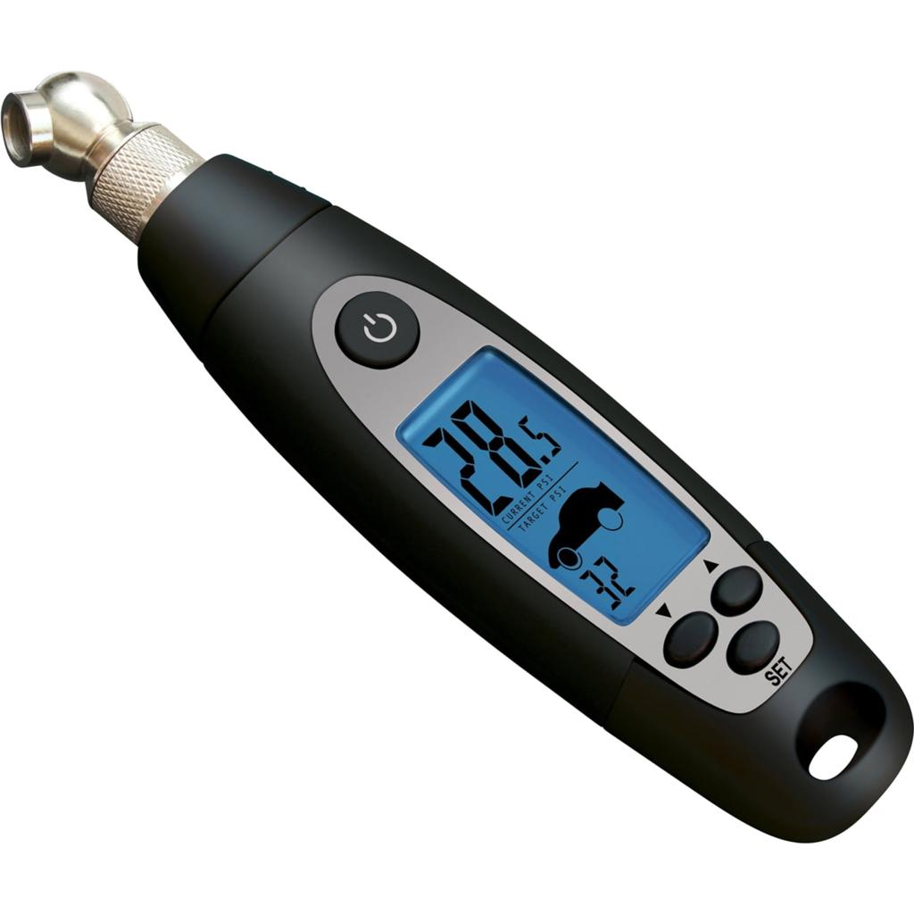
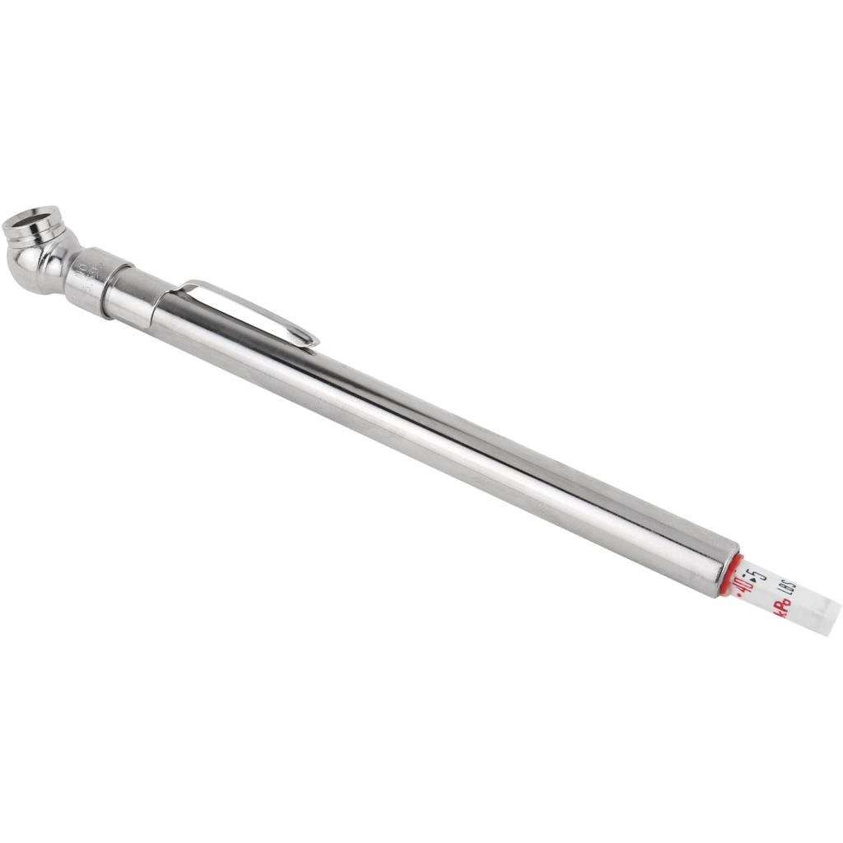
7
Description
A Tire Pressure Gauge is a portable instrument specifically designed to measure the air pressure inside vehicle tires. It helps maintain the correct tire pressure for safety, fuel efficiency, tire longevity, and optimal vehicle performance.
Features
- Compact and portable
- Easy to use
- Available in analog and digital versions
- Measures tire inflation pressure accurately
- Some models include backlit displays and pressure-release valves
Applications
- Passenger cars
- Motorcycles
- Trucks
- Bicycles
- Buses
- Off-road vehicles
- Aircraft tires (specialized models)

Measuring Units
# Source: AI Source: Provided by: [Data Path: Persons Table -> ID Column: 1, Name_En Column: Motasem Essam] -> From: [ChatGPT] on [7/17/2026]
Pressure gauges commonly display:
- Pascal (Pa)
- Kilopascal (kPa)
- Megapascal (MPa)
- Bar
- Millibar (mbar)
- Pounds per square inch (psi)
- Atmosphere (atm)

Measuring Range
# Source: AI Source: Provided by: [Data Path: Persons Table -> ID Column: 1, Name_En Column: Motasem Essam] -> From: [ChatGPT] on [7/17/2026]
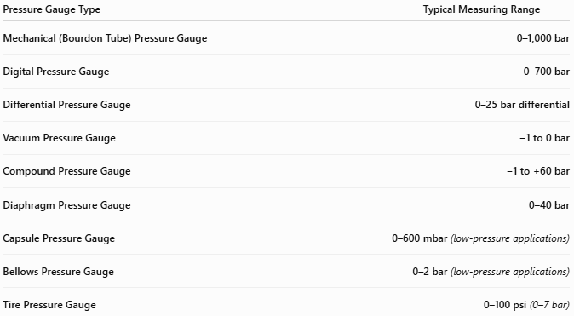
Pressure Gauge Type | Typical Measuring Range
Mechanical (Bourdon Tube) Pressure Gauge | 0–1,000 bar
Digital Pressure Gauge | 0–700 bar
Differential Pressure Gauge | 0–25 bar differential
Vacuum Pressure Gauge | −1 to 0 bar
Compound Pressure Gauge | −1 to +60 bar
Diaphragm Pressure Gauge | 0–40 bar
Capsule Pressure Gauge | 0–600 mbar (low-pressure applications)
Bellows Pressure Gauge | 0–2 bar (low-pressure applications)
Tire Pressure Gauge | 0–100 psi (0–7 bar)

Resolution
# Source: AI Source: Provided by: [Data Path: Persons Table -> ID Column: 1, Name_En Column: Motasem Essam] -> From: [ChatGPT] on [7/17/2026]
Resolution is the smallest pressure increment displayed.
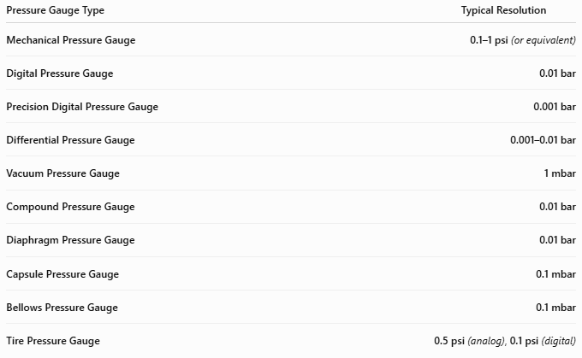
Pressure Gauge Type | Typical Resolution
Mechanical Pressure Gauge | 0.1–1 psi (or equivalent)
Digital Pressure Gauge | 0.01 bar
Precision Digital Pressure Gauge | 0.001 bar
Differential Pressure Gauge | 0.001–0.01 bar
Vacuum Pressure Gauge | 1 mbar
Compound Pressure Gauge | 0.01 bar
Diaphragm Pressure Gauge | 0.01 bar
Capsule Pressure Gauge | 0.1 mbar
Bellows Pressure Gauge | 0.1 mbar
Tire Pressure Gauge | 0.5 psi (analog), 0.1 psi (digital)

Accuracy
# Source: AI Source: Provided by: [Data Path: Persons Table -> ID Column: 1, Name_En Column: Motasem Essam] -> From: [ChatGPT] on [7/17/2026]
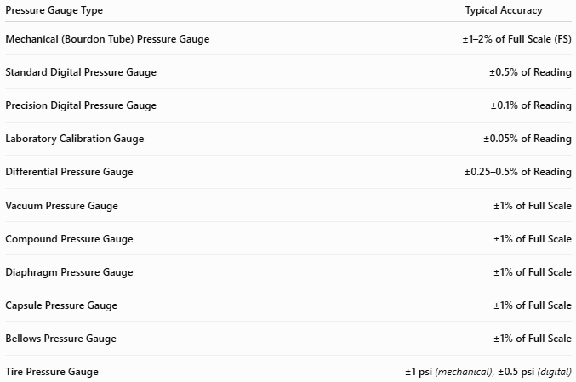
Pressure Gauge Type | Typical Accuracy
Mechanical (Bourdon Tube) Pressure Gauge | ±1–2% of Full Scale (FS)
Standard Digital Pressure Gauge | ±0.5% of Reading
Precision Digital Pressure Gauge | ±0.1% of Reading
Laboratory Calibration Gauge | ±0.05% of Reading
Differential Pressure Gauge | ±0.25–0.5% of Reading
Vacuum Pressure Gauge | ±1% of Full Scale
Compound Pressure Gauge | ±1% of Full Scale
Diaphragm Pressure Gauge | ±1% of Full Scale
Capsule Pressure Gauge | ±1% of Full Scale
Bellows Pressure Gauge | ±1% of Full Scale
Tire Pressure Gauge | ±1 psi (mechanical), ±0.5 psi (digital)

Notes
- Digital pressure gauges generally provide higher accuracy and finer resolution than mechanical gauges.
- Capsule and bellows gauges are designed for very low-pressure measurements and offer finer low-range resolution.
- Differential pressure gauges measure the pressure difference between two points rather than absolute pressure.
- Tire pressure gauges are optimized for vehicle tire inflation and typically measure from 0–100 psi (0–7 bar).
- Pressure gauge accuracy depends on calibration, operating temperature, vibration, and correct installation.

How to Use a Pressure Gauge
# Source: AI Source: Provided by: [Data Path: Persons Table -> ID Column: 1, Name_En Column: Motasem Essam] -> From: [ChatGPT] on [7/17/2026]
- Connect the gauge securely to the pressure source.
- Ensure there are no leaks.
- Apply pressure gradually.
- Read the pressure value from the dial or digital display.
- Release pressure safely after measurement.

Applications
# Source: AI Source: Provided by: [Data Path: Persons Table -> ID Column: 1, Name_En Column: Motasem Essam] -> From: [ChatGPT] on [7/17/2026]
Pressure gauges are used in:
- Hydraulic systems
- Pneumatic systems
- Boilers
- Compressors
- HVAC systems
- Chemical processing
- Water treatment
- Oil and gas industry
- Power plants
- Laboratories

Advantages
# Source: AI Source: Provided by: [Data Path: Persons Table -> ID Column: 1, Name_En Column: Motasem Essam] -> From: [ChatGPT] on [7/17/2026]
A pressure gauge:
- Provides real-time pressure measurement.
- Is simple to operate.
- Available in many pressure ranges.
- Offers both analog and digital options.
- Requires little maintenance.

Limitations
# Source: AI Source: Provided by: [Data Path: Persons Table -> ID Column: 1, Name_En Column: Motasem Essam] -> From: [ChatGPT] on [7/17/2026]
A pressure gauge:
- Requires periodic calibration.
- Mechanical gauges may wear over time.
- Can be damaged by overpressure.
- Digital models require battery power.

Sources of Error
# Source: AI Source: Provided by: [Data Path: Persons Table -> ID Column: 1, Name_En Column: Motasem Essam] -> From: [ChatGPT] on [7/17/2026]
Instrument Errors
- Calibration drift
- Sensor wear
- Pointer friction (mechanical gauges)

User Errors
- Improper installation
- Reading from an angle (parallax error)
- Using the wrong pressure range

Environmental Errors
- Temperature changes
- Vibration
- Corrosive environments
- Pressure pulsations

Comparison with Other Pressure Measuring Instruments
# Source: AI Source: Provided by: [Data Path: Persons Table -> ID Column: 1, Name_En Column: Motasem Essam] -> From: [ChatGPT] on [7/17/2026]
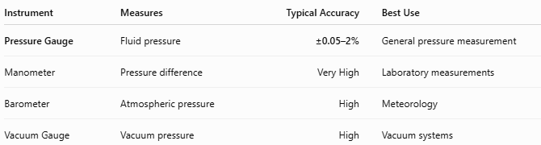
Instrument | Measures | Typical Accuracy | Best Use
Pressure Gauge | Fluid pressure | ±0.05–2% | General pressure measurement
Manometer | Pressure difference | Very High | Laboratory measurements
Barometer | Atmospheric pressure | High | Meteorology
Vacuum Gauge | Vacuum pressure | High | Vacuum systems

Care and Maintenance
# Source: AI Source: Provided by: [Data Path: Persons Table -> ID Column: 1, Name_En Column: Motasem Essam] -> From: [ChatGPT] on [7/17/2026]
To maintain accuracy:
- Avoid overpressure.
- Calibrate periodically.
- Protect from vibration.
- Keep connections clean.
- Replace damaged gauges immediately.

Common Mistakes
# Source: AI Source: Provided by: [Data Path: Persons Table -> ID Column: 1, Name_En Column: Motasem Essam] -> From: [ChatGPT] on [7/17/2026]
- Exceeding the maximum pressure rating.
- Ignoring calibration intervals.
- Installing the gauge incorrectly.
- Selecting an inappropriate pressure range.

Key Points
# Source: AI Source: Provided by: [Data Path: Persons Table -> ID Column: 1, Name_En Column: Motasem Essam] -> From: [ChatGPT] on [7/17/2026]
- A Pressure Gauge measures the pressure of gases or liquids.
- Common types:
  - Bourdon Tube Pressure Gauge
  - Digital Pressure Gauge
  - Differential Pressure Gauge
  - Vacuum Pressure Gauge
  - Compound Pressure Gauge
  - Diaphragm Pressure Gauge
- Common units:
  - Pascal (Pa)
  - Bar
  - psi
  - MPa
  - atm

Conclusion
# Source: AI Source: Provided by: [Data Path: Persons Table -> ID Column: 1, Name_En Column: Motasem Essam] -> From: [ChatGPT] on [7/17/2026]
A Pressure Gauge is an essential measuring instrument for monitoring the pressure of gases and liquids in industrial, laboratory, and commercial systems. Available in mechanical and digital forms, and with specialized designs such as Bourdon tube, diaphragm, differential, vacuum, and compound gauges, it provides reliable pressure measurements that help ensure safe operation, process control, equipment protection, and quality assurance across a wide range of applications.

